## 

## A

## Project Report

## on

# **TRAINING MANAGEMENT SYSTEM**

# **BTech-IT, Sem VI**

Prepared By:

Harshil Patel (IT096)

Guided By:

Prof. Deepak C. Vegada

Department of Information Technology



##### **Department of Information Technology**

**Faculty of technology,**

**Dharmsinh Desai University**

**College road, Nadiad- 387001**

**April, 2024**

**CANDIDATE’S DECLARATION**

I/We declare that 6th semester report entitled “Training Management System” is my /our own work conducted under the supervision of the guide Prof. Deepak C Vegada.

We further declare that to the best of our knowledge the report for B.Tech. VI semester does not contain part of the work which has been submitted either in this or any other university without proper citation.

Candidate’s Signature

Candidate’s Name: Harshil Patel

Student ID: 21ITUON151

**DHARMSINH DESAI UNIVERSITY**

## NADIAD-387001, GUJARAT



**CERTIFICATE**

This is to certify that the project carried out in the subject of System Design Practice, entitled “Training Management System” and recorded in this report is a bonafide report of work of

|  |  |  |
| --- | --- | --- |
| 1) Harshil Patel | Roll No. IT096 | ID No:21ITUON151 |

of the Department of Information Technology, semester VI. They were involved in Project work during the academic year 2023 – 2024.

Prof. Deepak C. Vegada (Project Guide)

Department of Information Technology,

Faculty of Technology,

Dharmsinh Desai University, Nadiad

Date:

Prof. (Dr.) Vipul K. Dabhi,

Head, Department of Information Technology, Faculty of Technology,

Dharmsinh Desai University, Nadiad

Date:

# 

# **ACKNOWLEDGEMENT**

On the very outset of this report, we would like to extend our sincere & heartfelt obligations towards all the personages who have directly or indirectly helped in this endeavor. Without their active guidance, help, cooperation & encouragement, we wouldn’t have made the headway in the project.

We are ineffably indebted to our instructor **Prof. Deepak C. Vegada** for guidance, encouragement and conscientiousness to accomplish this project. We are extremely thankful for his support.

We would also like to express our gratitude to our Head, **Dr. Vipul Dabhi**along with Dharmsinh Desai University for giving us this opportunity.

Any omission in this brief acknowledgement does not mean lack of gratitude.

**Thank You,**

**Harshil Patel**

# **TABLE OF CONTENTS**

ABSTRACT i

LIST OF FIGURES ii

LIST OF TABLE iii

1 INTRODUCTION 1

1.1 INTRODUCTION 1

1.2 PURPOSE 1

1.3 SCOPE 1

1.4 OBJECTIVE 1

1.5 TECHNOLOGY AND LITERATURE REVIEW 2

2 PROJECT MANAGEMENT 3

2.1 FEASIBILITY STUDY 3

2.1.1 Technical Feasibility 3

2.1.2 Time Schedule Feasibility 3

2.1.3 Operational Feasibility 3

2.1.4 Implementation Feasibility 3

2.2 PROJECT PLANNING 5

2.2.1 Project Development Approach and Justification 5

2.2.2 Project Plan 7

2.2.3 Milestones and Deliverables 7

2.2.4 Roles And Responsibilities 8

2.2.5 Group Dependencies 9

2.3 PROJECT SCHEDULING 9

3 SYSTEM REQUIREMENTS 10

3.1 STUDY OF CURRENT SYSTEM 10

3.2 PROBLEMS AND WEAKNESS OF CURRENT SYSTEM 10

3.3 USER CHARACTERISTICS 10

3.4 HARDWARE AND SOFTWARE REQUIREMENTS 11

3.5 CONSTRAINTS 12

3.5.1 Regulatory Policies 12

3.5.2 Hardware Limitations 13

3.5.3 Interfaces to Other Application 13

3.5.4 Parallel Operation 13

3.5.5 Higher Order Language Requirements 13

3.5.6 Reliability Requirements 14

3.5.7 Criticality of the Application 14

3.5.8 Safety and Security Consideration 14

3.6 ASSUMPTIONS AND DEPENDENCIES 14

4 SYSTEM ANALYSIS 16

4.1 REQUIREMENT OF NEW SYSTEM 16

4.1.1 User Requirements 16

4.1.2 System Requirements 16

4.1.3 Non-Functional Requirements 19

4.2 FEATURES OF NEW SYSTEM 19

4.3 NAVIGATION CHART 20

4.4 SYSTEM ACTIVITY 21

4.5 DATA MODELING 22

4.5.1 Data Dictionary **Error! Bookmark not defined.**

4.5.2 ER Diagram **Error! Bookmark not defined.**

5 SYSTEM DESIGN 24

5.1 SYSTEM ARCHITECTURE DESIGN 24

5.1.1 Class Diagram 24

5.1.2 Sequence Diagram 25

5.1.3 Component Diagram 26

5.1.4 Deployment Diagram 27

5.2 USECASE DIAGRAM 28

5.3 ACTIVITY DIAGRAM 29

5.4 DATA FLOW DIAGRAM 30

5.4.1 Level-0 (Context level) 30

5.4.2 Level-1 (Context level) 30

5.4.3 Level-2 (Context level) 31

5.5 STATECHART DIAGRAM 32

6 IMPLEMENTATION PLANNING 33

6.1 IMPLEMENTATION ENVIRONMENT 33

6.2 PROGRAM/MODULES SPECIFICATION 33

6.3 CODING STANDARDS 34

7 TESTING 38

7.1 TESTING PLAN 38

7.2 TESTING STRATEGY 39

7.3 TESTING METHODS 40

7.4 TEST CASES 40

8 USER MANUAL 41

9 LIMITATIONS AND FUTURE ENHANCEMENT 56

9.1 LIMITATIONS 56

9.2 FUTURE ENHANCEMENTS 56

10 CONCLUSION AND DISCUSSION 57

10.1 CONCLUSION 57

10.2 DISCUSSION 57

10.2.1 Self-Analysis of Project Viabilities 57

10.2.2 Problems Encountered and Possible Solutions 57

10.2.3 Summary of Project Work 57

REFERENCES: 58

**ABSTRACT**

Unlock the potential of your training programs with our dynamic Online Training Management System (TMS), powered by the innovative MERN stack. Seamlessly navigate through intuitive interfaces and embark on personalized learning journeys tailored to your goals. Stay engaged with real-time progress tracking and interactive collaboration tools that amplify your learning experience. With robust reporting and scalable security features, our TMS ensures your success in today's dynamic world. Dive in, elevate your skills, and watch your organization thrive!

# **LIST OF FIGURES**

Figure 2.1 IMPLEMENTATION FEASIBILITY 4

Figure 2.2 PROJECT SCHEDULING CHART 9

Figure 4.1 NAVIGATION CHART FOR USER 20

Figure 4.2 NAVIGATION CHART FOR ADMIN 20

Figure 4.3 NAVIGATION CHART FOR INSTRUCTOR 21

Figure 4.4 ER Diagram 23

Figure 5.1 CLASS DIAGRAM 24

Figure 5.2 SEQUENCE DIAGRAM 25

Figure 5.3 COMPONENT DIAGRAM 26

Figure 5.4 DEPLOYMENT DIAGRAM 27

Figure 5.5 USECASE DIAGRAM 28

Figure 5.6 ACTIVITY DIAGRAM 29

Figure 5.7 DFD LEVEL-0 30

Figure 5.8 DFD LEVEL-1 30

Figure 5.9 DFD LEVEL-2 31

Figure 5.10 STATECHART DIAGRAM 32

Figure 6.1 Index.js 35

Figure 6.2 main.jsx 35

Figure 6.3 AuthProvider.jsx 36

Figure 6.4 useAxiosFetch..jsx 36

Figure 8.1 HOME PAGE 41

Figure 8.2 OUR GALLARY 41

Figure 8.3 POPULAR CLASSES 42

Figure 8.4 TEACHERS 42

Figure 8.5 NEWSLETTER 43

Figure 8.6 INSTRUCTOR PAGE 43

Figure 8.7 CLASSES PAGE 44

Figure 8.8 USER DASHBOARD 44

Figure 8.9 SELECTED CLASSES 45

Figure 8.10 PAYMENT MODULE 45

Figure 8.11 PAYMENT HISTORY 46

Figure 8.12 APPLICATION FOR INSTRUCTOR 46

Figure 8.13 SIGN UP PAGE 47

Figure 8.14 SIGN-IN PAGE 47

Figure 8.15 ADMIN DASHBOARD 48

Figure 8.16 MANAGE USERS 48

igure 8.17 MANAGE CLASSES-PENDING CLASS 49

Figure 8.18 MANAGE CLASSES-APPROVED CLASS 49

Figure 8.19 INSTRUCTOR DASHBOARD 50

Figure 8.20 ADD YOUR CLASS 50

Figure 8.21 ADD YOUR CLASS DETAILS 51

Figure 8.22 DETAILS SUBMITTED SUCCESSFULLY 51

Figure 8.23 INSTRUCTOR CLASSES PAGE 52

Figure 8.24 REQUEST IN ADMIN MODULE 52

Figure 8.25 CLASS APPROVED BY ADMIN 53

Figure 8.26 NEW CLASS ADDED TO CLASSES 53

Figure 8.27 POPULAR CLASSSES- DARK MODE 54

Figure 8.28 CLASSES- DARK MODE 54

Figure 8.29 LOGOUT PAGE 55

**LIST OF TABLE**

Table 2.1 PROJECT PLAN 7

Table 2.2 ROLES AND RESPONSIBILITIES 8

Table 2.3 GROUP DEPENDENCIES 9

Table 4.1 USERS DATA 22

Table 4.2 CLASSES DATA 23

Table 4.3 Cart Data 23

Table 4.4 Applied Data 23

Table 7.1 TEST CASES 40

# **INTRODUCTION**

## INTRODUCTION

Embark on a journey of continuous learning and professional development with the Online Training Management System (TMS). Imagine a virtual basis where knowledge flows seamlessly, accessible from the comfort of your workplace desk or the coziness of your home sofa. Say goodbye to rigid schedules and hello to 24/7 availability as TMS invites you to explore a world of possibilities with just a click. Picture yourself logging in with your personalized User ID and Password, unlocking a treasure trove of learning resources tailored to your needs.

At the heart of TMS lies a commitment to convenience and accessibility. No longer confined to physical classrooms or restrictive time slots, learners can delve into a wealth of course materials anytime, anywhere. Whether you're a busy professional squeezing in study sessions during lunch breaks or a dedicated learner craving midnight inspiration, TMS is your steadfast companion, always at your service.

But TMS is more than just a repository of information; it's a vibrant community buzzing with collaboration and interaction. Imagine engaging in lively discussions with peers from across the globe, sharing insights, and challenging perspectives. With intuitive communication tools seamlessly integrated into the platform, fostering meaningful connections has never been easier. From group projects to virtual study sessions, TMS transforms solitary learning into a captivating social experience.

Tracking progress has never been more engaging than with TMS's dynamic tracking features. Visualize your learning journey unfolding before your eyes, as you monitor completion rates, quiz scores, and skill development in real-time. With personalized dashboards and insightful analytics at your fingertips, charting your growth becomes an exhilarating adventure, motivating you to reach new heights of excellence.

In a world where knowledge is power, TMS empowers you to unleash your full potential. With its seamless blend of accessibility, collaboration, and progress tracking, TMS revolutionizes the way you learn and grow. So why wait? Take the plunge into the world of online learning with TMS, where every click brings you closer to success.

## PURPOSE

The purpose of an Training Management System (TMS) is to revolutionize the way organizations deliver, manage, and track their training programs. Its primary objectives include:

Accessibility: TMS aims to provide easy access to training materials and resources anytime, anywhere, fostering a culture of continuous learning among employees or learners.

Efficiency: By automating various administrative tasks such as course scheduling, enrollment, and progress tracking, TMS streamlines the training process, saving time and resources for both trainers and learners.

Engagement: TMS enhances learner engagement through interactive features such as discussion forums, collaborative projects, and multimedia content, making learning more enjoyable and effective.

Personalization: TMS allows for personalized learning paths tailored to individual learners' needs, preferences, and skill levels, ensuring that training programs are relevant and impactful.

Performance Tracking: TMS provides robust analytics and reporting tools to monitor learner progress, assess training effectiveness, and identify areas for improvement, enabling organizations to make data-driven decisions.

Scalability: TMS is designed to accommodate the growing needs of organizations, whether they are scaling up their training programs or expanding their workforce, ensuring flexibility and adaptability.

Compliance: TMS helps organizations ensure regulatory compliance by tracking and documenting training activities, certifications, and compliance requirements, reducing the risk of non-compliance penalties.

Overall, the purpose of an TMS is to empower organizations to effectively manage their training initiatives, enhance employee skills and knowledge, and ultimately drive organizational success.

## SCOPE

The scope of an Training Management system encompasses the features, functionalities, and services that the system will provide to meet the needs of its users. The scope can vary depending on the specific requirements and goals of the Training Management system platform, but some common aspects include: course management, user management, content management, communication and collaboration, assessment and feedback, progress tracking and reporting, accessibility and compatibility, privacy and security, integration and customization, support and management.

User Management: Efficiently manage user roles, permissions, and profiles for trainers, trainees, and administrators.

Course Management: Create, organize, and schedule training courses, including assigning trainers and setting prerequisites.

Content Management: Upload, organize, and update training materials such as documents, videos, and quizzes.

Progress Tracking: Monitor user progress, including course completion rates and assessment scores, with reporting tools.

Communication Tools: Facilitate interaction between trainers and trainees through messaging systems and discussion forums.

Scalability: Ensure the system can accommodate growing numbers of users and courses.

Security: Implement measures to protect user data and ensure compliance with relevant regulations.

This condensed scope covers the essential features and functionalities of an OTMS while maintaining brevity.

## OBJECTIVE

The training management system is designed to help organizations manage all aspects of their commercial training. A TMS is a centralized platform for creating and scheduling courses and presenters, tracking payments and business Accessibility: Ensure easy access to training materials from any location, facilitating seamless learning experiences for usersgrowth.

Efficiency: Streamline administrative tasks like course creation, enrollment, and progress tracking to save time and resources.

Personalization: Tailor learning paths to individual needs, preferences, and skill levels for a more engaging and effective learning experience.

Engagement: Foster collaboration and interaction among learners through discussion forums and group activities, enhancing overall engagement.

Progress Tracking: Monitor user progress and performance metrics to assess learning outcomes and identify areas for improvement.

Data Analysis: Provide administrators with insights and analytics to make informed decisions about training program design and resource allocation.

Compliance and Security: Ensure compliance with regulatory requirements and implement robust security measures to protect user data.

Scalability: Design the system to accommodate growing user numbers and evolving organizational needs without compromising performance.

Feedback Mechanism: Incorporate feedback mechanisms to gather user input and continuously improve the system based on user needs and preferences.

ROI Optimization: Maximize the return on investment by delivering effective training programs that contribute to improved employee performance and organizational success.

## TECHNOLOGY AND LITERATURE REVIEW

Technology:

Frontend: React JS

Backend: Express JS, Node JS, Mongo DB.

Literature Review:

Training Management Systems (TMS) have evolved to streamline course creation, scheduling, and payment tracking. Challenges include integration complexity and ensuring user adoption, while benefits include enhanced efficiency and improved accessibility. Continued innovation is essential to strengthen the role of online TMS in effective training program management.

# **PROJECT MANAGEMENT**

## FEASIBILITY STUDY

### **Technical Feasibility**

Technical feasibility of Training Management System involves addressing various challenges such as data storage management, computational efficiency, and issues like the cold start problem and data sparsity due to the vast scale of information. To overcome these challenges, comprehensive analysis and study of Training Management system are crucial. Hybrid recommendation algorithms, particularly those based on collaborative filtering, are designed to enhance the technical feasibility and efficacy of e-learning platforms.

### **Time Schedule Feasibility**

Time schedule feasibility of e-learning entails ensuring that learning activities, including course delivery, assessments, and interactions, adhere to predefined schedules and deadlines. This involves efficient planning and allocation of resources to meet the educational objectives within stipulated timeframes. Implementation of e-learning platforms requires careful consideration of time constraints for content creation, system development, and user training to ensure timely deployment and effectiveness of the educational initiatives.

### **Operational Feasibility**

From Operational feasibility of e-learning refers to the system's ability to function effectively within the existing operational environment of an organization or educational institution. This involves assessing whether the e-learning platform can be seamlessly integrated into existing processes and workflows without significant disruptions or resistance from users. Factors such as user acceptance, technical compatibility, and administrative support play crucial roles in determining operational feasibility. Conducting thorough user training, providing technical support, and ensuring alignment with organizational goals are essential for achieving operational feasibility in e-learning implementations. Additionally, evaluating the scalability and sustainability of the e-learning solution over time is necessary to ensure its long-term viability within the operational context.

### **Implementation Feasibility**

The Assessing the implementation feasibility of an online Training Management System (TMS) involves evaluating technical readiness, resource availability, scalability, security measures, user acceptance, regulatory compliance, integration capabilities, training, support, and return on investment. Organizations need to ensure they have the technological infrastructure, financial resources, and manpower required for development and maintenance. The TMS should be scalable to accommodate growing training needs and secure to protect sensitive data. User acceptance and regulatory compliance are crucial, along with seamless integration with existing systems. Adequate training and ongoing support for users are essential for successful implementation. Ultimately, conducting a cost-benefit analysis helps determine whether the investment in the TMS will yield

significant returns for the organization.

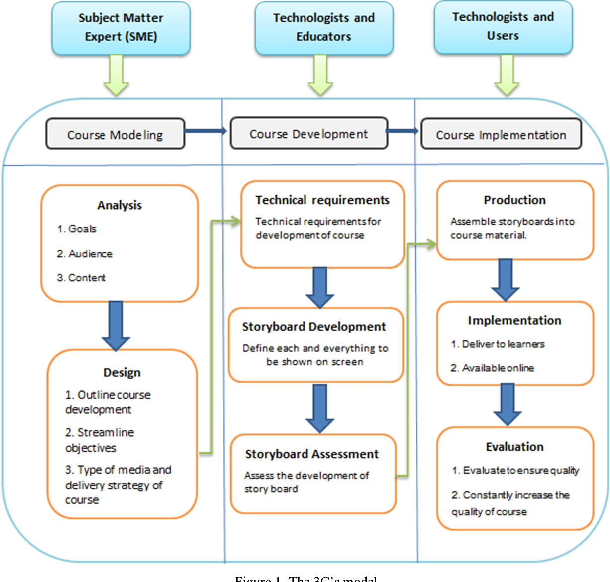

Figure 2.1 IMPLEMENTATION FEASIBILITY

## PROJECT PLANNING

### **Project Development Approach and Justification**

1. In In Project Development Approach:

Agile Methodology:

* Iterative Development: Adopt an Agile methodology to enable iterative development, allowing for continuous feedback and adaptation to changing requirements.
* Sprints: Divide the project into sprints, each focusing on delivering specific features or functionalities.

User-Centric Design:

* User Stories: Gather user stories to understand the needs and pain points of stakeholders, including trainers, trainees, and administrators.
* Prototyping: Develop prototypes early in the process to visualize the system and gather feedback from users.

Technology Stack:

* Scalability: Choose a technology stack that allows for scalability to accommodate growing numbers of users and courses.
* Security: Implement robust security measures to protect sensitive training data and user information.

Continuous Integration and Deployment (CI/CD):

* Automated Testing: Implement automated testing to ensure the reliability and quality of the system.
* Continuous Deployment: Utilize CI/CD pipelines to automate the deployment process, allowing for frequent updates and enhancements.

1. Justification:

Efficiency and Cost Savings:

* Streamlined Processes: An online TMS automates manual processes such as course scheduling, registration, and tracking, leading to increased efficiency.
* Reduced Administrative Burden: Automated administrative tasks free up time for trainers and administrators to focus on delivering quality training content.

Accessibility and Flexibility:

* Anywhere, Anytime Access: Online training allows participants to access materials and complete courses remotely, improving accessibility and flexibility.
* Self-Paced Learning: Trainees can progress through courses at their own pace, accommodating different learning styles and schedules.

Data-driven Decision Making:

* Insightful Analytics: A TMS provides valuable insights through analytics and reporting, allowing organizations to track learner progress, identify trends, and make data-driven decisions to improve training effectiveness.

Scalability and Growth:

* Support for Expansion: As organizations grow or training needs evolve, an online TMS can easily scale to accommodate increased demand for courses and users.
* Global Reach: With an online platform, organizations can reach a wider audience, including remote employees or international partners.

Compliance and Regulation:

* Compliance Management: Ensure adherence to regulatory requirements and industry standards by implementing features such as certification tracking and compliance reporting within the TMS.

In conclusion, by adopting an Agile development approach and justifying the implementation based on efficiency gains, accessibility, data-driven decision-making, scalability, and compliance needs, organizations can successfully develop and implement an online Training Management System tailored to their specific requirements and objectives.

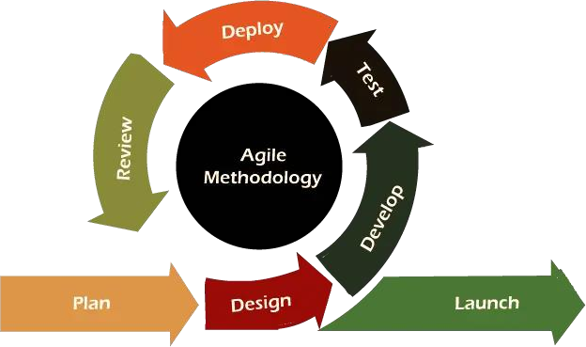

Figure 2.2 AGILE MODEL

### **Project Plan**

Table 2.1 PROJECT PLAN

|  |  |  |
| --- | --- | --- |
| **Sr. No.** | **Documents** | **Timeline** |
| 1 | Project Definition, Submission and approval | 8 January |
| 2 | Project analysis and design | 15 January |
| 3 | Development | 20 February |
| 4 | Testing | 1 March |
| 5 | Documentation | 26 March |
| 6 | Deployment | 4 Aprill |

### **Milestones and Deliverables**

Phase 1: Planning and Requirements (1-2 Weeks)

Milestone: Project Plan Finalized

Deliverables:

• Requirements Document:

• Target Users

• Project Goals

• Data Sources

• Evaluation Metrics

Approaches:

• Agile Methodology

• User Stories Creation

• Wireframing and Prototyping

Phase 2: System Design (2-3 Weeks)

Milestone: System Architecture Defined

Deliverables:

• High-level System Architecture Diagram

• Database Schema

• User Interface Design

Approaches:

• Design Patterns

• Component-based Architecture

• Scalability Planning

Phase 3: Development (4-6 Weeks) report with feedback on usability and recommendations.

Milestone: Core Features Implemented

Deliverables:

* User Authentication and Authorization
* Course Creation and Management
* Content Delivery System
* Assessment and Progress Tracking

Approaches:

* MERN Stack Development
* RESTful API Design
* Component-based Frontend Development

Phase 4: Testing and Quality Assurance (2 Weeks)

Milestone: System Testing Completed

Deliverables:

* Test Plan Document
* Unit Testing
* Integration Testing
* User Acceptance Testing

Approaches:

* Test-Driven Development (TDD)
* Continuous Integration (CI)
* Bug Tracking and Resolution

Phase 5: Deployment and Launch (1 Week)

Milestone: System Deployed to Production Environment

Deliverables:

* Deployed Application on Cloud Server
* User Documentation
* Administrator Training Materials

Approaches:

* Cloud Deployment (e.g., AWS, Heroku)
* Continuous Deployment (CD)
* DevOps Practices

Phase 6: Post-launch Monitoring and Maintenance (Ongoing)

Milestone: System Stable and Functional

Deliverables:

* Monitoring Reports
* Performance Optimization Recommendations
* Bug Fixes and Updates

Approaches:

* Performance Monitoring
* Scalability Enhancements
* Feature Updates and Enhancements

### **Roles And Responsibilities**

Table 2.2 ROLES AND RESPONSIBILITIES

|  |  |  |  |  |  |  |  |
| --- | --- | --- | --- | --- | --- | --- | --- |
| **Name** | **Analysis** | **Research** | **Design** | **Coding** | **Testing** | **Documentation** | **Maintenance** |
| Harshil | **√** | **√** | **√** | **√** | **√** | **√** | **√** |

### **Group Dependencies**

Table 2.3 GROUP DEPENDENCIES

|  |  |
| --- | --- |
| **Name** | **Dependencies** |
| Data Management | MongoDB, Mongoose |
| Backend Development | Node JS, Express JS |
| Frontend Development | React JS, Redux, Axios, Material-UI |

## PROJECT SCHEDULING

* + 1. **Project Scheduling Chart**

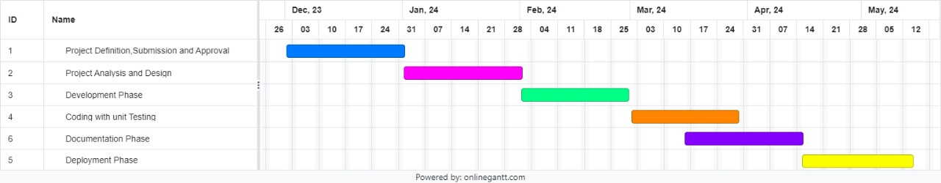

Figure 2.2 PROJECT SCHEDULING CHART

# **SYSTEM REQUIREMENTS**

## STUDY OF CURRENT SYSTEM

The current Online Training Management System (TMS) serves as a centralized platform for managing training activities but faces challenges in user experience, limited functionality, manual data management, scalability, and security. The interface lacks modern design elements, while manual data entry leads to inefficiencies and errors. To improve the system, enhancements such as UI redesign, automation of tasks, integration with other systems, scalability optimization, and security upgrades are recommended. These improvements aim to create a more user-friendly, efficient, and secure TMS that meets the evolving needs of trainers, trainees, and administrators, enhancing the overall training experience and outcomes.

## PROBLEMS AND WEAKNESS OF CURRENT SYSTEM

The current Online Training Management System (TMS) faces several challenges and weaknesses that hinder its effectiveness and usability:

**User Interface Limitations:**

•The interface lacks modern design elements and intuitive navigation, leading to user frustration and difficulty in accessing key features efficiently.

**Limited Functionality:**

•Basic functionalities are present, but the system lacks advanced features required for comprehensive training management, such as interactive learning materials and social learning capabilities.

**Manual Data Management:**

•Data entry processes are primarily manual, resulting in inefficiencies, errors, and duplication of efforts. Lack of integration with other systems exacerbates data silos and hampers data consistency.

**Scalability Concerns:**

•As the number of users and courses grows, the system's scalability becomes a concern. Performance issues, including slow loading times and occasional downtime, arise during peak usage periods.

**Security Vulnerabilities:**

•While basic security measures are in place, the system lacks robust security features, leaving it vulnerable to potential breaches and data leaks. Compliance with regulatory requirements, such as GDPR, is not fully ensured.

Addressing these problems and weaknesses is crucial for enhancing the overall functionality, usability, and security of the TMS, ultimately improving the training experience for users and administrators alike.

## USER CHARACTERISTICS

In the context of the Online Training Management System (TMS), there are three primary user roles:

1. **Administrator:**

* Responsibilities: Administrators oversee the overall operation of the TMS. They manage user accounts, course catalog, and system configurations.
* Actions: Administrators can create, edit, and delete user accounts, manage course schedules, and generate reports on training activities.
* Characteristics: Administrators possess administrative privileges and have comprehensive access to system features for maintenance and oversight.

1. **Instructor:**

* Responsibilities: Instructors manage classes and deliver training content to trainees. They create course materials, schedule classes, and assess trainee performance.
* Actions: Instructors can create and edit course content, schedule classes, enroll trainees in courses, and track their progress.
* Characteristics: Instructors possess teaching expertise and have specialized access to course management tools within the TMS.

1. **Trainee:**

* Responsibilities: Trainees participate in training courses within the TMS to acquire knowledge and skills relevant to their roles.
* Actions: Trainees can enroll in available courses, access course materials, complete assignments, and track their progress.
* Characteristics: Trainees vary in their levels of experience and proficiency. They primarily interact with the TMS to engage with course content and monitor their learning progress.

By delineating the distinct roles and responsibilities of administrators, instructors, and trainees, the TMS can be tailored to meet the specific needs of each user group, facilitating efficient course management, effective instruction, and engaging learning experiences.

## HARDWARE AND SOFTWARE REQUIREMENTS

Hardware Requirements:

1. Server:

* A robust server infrastructure capable of hosting the Online Training Management System (TMS).
* Adequate processing power and memory to handle concurrent user requests and database operations.

1. Storage:

* Sufficient storage capacity to store training materials, user data, and system logs.
* Consideration of scalability to accommodate future growth in data volume.

1. Networking Equipment:

* Reliable network infrastructure with sufficient bandwidth to support seamless communication between users and the TMS server.
* Implementation of network security measures, such as firewalls and intrusion detection/prevention systems.

1. Client Devices:

* Compatibility with a variety of client devices, including desktop computers, laptops, tablets, and smartphones.
* Consideration of device specifications, screen sizes, and input methods for optimal user

experience across different platforms.

Software Requirements:

1. Operating System:

* Server-side operating system such as Linux (e.g., Ubuntu, CentOS) or Windows Server for hosting the TMS application.
* Client-side operating systems including Windows, macOS, iOS, and Android for accessing the TMS interface.

1. Web Server:

* Installation of a web server software such as Apache HTTP Server, Nginx, or Microsoft Internet Information Services (IIS) to host the TMS application.

1. Database Management System (DBMS):

* Implementation of a reliable and scalable database management system to store and manage TMS data.
* Options include MySQL, PostgreSQL, Microsoft SQL Server, or MongoDB depending on requirements and preferences.

1. Programming Languages and Frameworks:

* Utilization of programming languages and frameworks for developing the TMS application.
* Common choices include JavaScript (Node.js) for server-side scripting, along with frameworks like Express.js, React.js, or Angular.js for building the user interface.

1. Security Software:

* Integration of security software and protocols to protect the TMS from cyber threats and unauthorized access.
* Implementation of SSL/TLS encryption, security patches, and regular vulnerability assessments to ensure system integrity.

1. Additional Tools and Libraries:

* Deployment of additional tools and libraries for enhancing TMS functionality, such as content management systems (CMS), version control systems, and analytics platforms.

By meeting these hardware and software requirements, organizations can ensure the reliable performance, security, and scalability of the Online Training Management System, providing users with a seamless and efficient training experience.



## CONSTRAINTS

### **Regulatory Policies**

The Online Training Management System (TMS) must adhere to regulatory policies to ensure legal compliance and protect user interests. This includes compliance with data privacy regulations like GDPR and CCPA, ensuring accessibility standards are met for users with disabilities, respecting intellectual property rights for training materials, implementing robust security measures such as

encryption, and adhering to export control regulations for international users. By addressing these constraints, the TMS can operate within legal boundaries while providing a secure and inclusive training environment.

### **Hardware Limitations**

The Online Training Management System (TMS) must consider hardware limitations to ensure optimal performance and usability. Key hardware constraints include server capacity, storage limitations, network bandwidth, and client device compatibility. Adequate server infrastructure with sufficient processing power and memory is essential to handle concurrent user requests and database operations. Additionally, storage capacity should be scalable to accommodate growing volumes of training materials and user data. Network bandwidth must be sufficient to support seamless communication between users and the TMS server, while client devices must be compatible to ensure an optimal user experience across various platforms. By addressing these hardware limitations, the TMS can provide reliable and efficient training management services to users.

### **Interfaces to Other Application**

Integration with other applications is crucial for the Online Training Management System (TMS) to maximize efficiency and functionality. Interfaces with existing systems, such as Human Resources Information Systems (HRIS) and Learning Management Systems (LMS), should be considered. Seamless data exchange between these systems ensures accurate user information and course enrollment data. Additionally, integration with content creation tools and communication platforms facilitates the development and delivery of training materials. Compatibility with industry-standard APIs allows for easy integration with third-party services and tools, enhancing the overall capabilities of the TMS. By prioritizing interfaces to other applications, the TMS can streamline processes and provide a more comprehensive training experience for users.

### **Parallel Operation**

The Online Training Management System (TMS) must accommodate parallel operations to support simultaneous user interactions and system tasks efficiently. Key considerations include scalability, concurrency control, and resource allocation. Scalability ensures the TMS can handle increasing loads of concurrent users without performance degradation. Effective concurrency control mechanisms prevent data corruption and ensure data consistency when multiple users access and modify the system simultaneously. Resource allocation strategies, such as load balancing and prioritization of critical tasks, optimize system performance during peak usage periods.

By addressing these constraints, the TMS can maintain responsiveness and reliability, providing a seamless training experience for users even under high demand conditions.

### **Higher Order Language Requirements**

The Online Training Management System (TMS) must support higher-order language requirements to accommodate diverse user preferences and linguistic needs. Key considerations include multilingual support, localization, and cultural adaptation. Multilingual support ensures that users can interact with the TMS interface and content in their preferred language, enhancing accessibility and inclusivity. Localization involves adapting the TMS to specific cultural norms, including date formats, currency symbols, and cultural references, to ensure a seamless user experience across different regions. Additionally, the TMS should facilitate content creation and delivery in multiple languages to cater to global audiences. By addressing these language requirements, the TMS can effectively reach and engage users from diverse linguistic backgrounds, fostering a more inclusive and accessible training environment.

### **Reliability Requirements**

The Online Training Management System (TMS) must meet reliability requirements to ensure consistent and uninterrupted service for users. Key considerations include system uptime, fault tolerance, and disaster recovery. The TMS should be designed with high availability in mind, minimizing downtime and ensuring access to training resources at all times. Implementing fault-tolerant mechanisms, such as redundancy and failover systems, mitigates the impact of hardware or software failures on system operation. Additionally, having robust disaster recovery plans and backup procedures in place safeguards against data loss and ensures quick recovery in the event of unforeseen incidents. By meeting these reliability requirements, the TMS can instill confidence in users and maintain productivity, even in challenging circumstances.

### **Criticality of the Application**

The Online Training Management System (TMS) is critical for organizational training initiatives and must be treated as such. Key considerations include system availability, data integrity, and user satisfaction. Any downtime or malfunction of the TMS can disrupt training schedules and impact organizational productivity. Therefore, high availability and reliability are paramount to ensure uninterrupted access to training materials and resources. Data integrity is also crucial to maintain the accuracy and validity of training records and assessments. Additionally, user satisfaction is essential for the success of the TMS, as it directly impacts user engagement and adoption. By recognizing the criticality of the application, stakeholders can prioritize investments in infrastructure, security, and support to ensure the TMS meets organizational training needs effectively and efficiently.

### **Safety and Security Consideration**

The safety and security of the Online Training Management System (TMS) are paramount to protect user data and ensure a secure learning environment. Key considerations include data encryption, access controls, and vulnerability management. Implementing robust encryption protocols safeguards sensitive user information, such as personal data and training records, from unauthorized access or breaches. Access controls should be enforced to restrict system access based on user roles and permissions, preventing unauthorized users from tampering with or accessing confidential data.

Additionally, proactive vulnerability management, including regular security audits and patch management, helps identify and mitigate potential security threats before they can be exploited. By prioritizing safety and security considerations, the TMS can instill trust among users and stakeholders, fostering a safe and secure learning environment for all participants.

## ASSUMPTIONS AND DEPENDENCIES

Assumptions:

* User Availability: It is assumed that users, including administrators, instructors, and trainees, will have reliable internet access and compatible devices to interact with the Online Training Management System (TMS).
* Training Content: The availability and quality of training content are assumed to meet the needs and expectations of users, providing relevant and engaging materials for effective learning.
* System Compatibility: The TMS is assumed to be compatible with commonly used web browsers and operating systems, ensuring a seamless user experience across different platforms.
* Training Compliance: It is assumed that training materials and activities within the TMS comply with relevant regulatory requirements and industry standards, ensuring legal compliance and adherence to best practices.

Dependencies:

* Technical Infrastructure: The successful operation of the TMS depends on the availability and reliability of technical infrastructure, including servers, databases, and networking equipment.
* Third-party Integration: Integration with external systems, such as HRIS and LMS, is dependent on the availability and compatibility of APIs and connectors provided by third-party vendors.
* Content Creation: The availability and timely creation of training content depend on the resources and efforts of content creators, including instructors and instructional designers.
* User Engagement: The effectiveness of the TMS relies on user engagement and participation, requiring proactive communication and support from administrators and instructors to encourage user involvement.

By acknowledging these assumptions and dependencies, stakeholders can better understand the context in which the TMS operates and plan accordingly to mitigate risks and ensure successful implementation and operation.

# **SYSTEM ANALYSIS**

## REQUIREMENT OF NEW SYSTEM

### **User Requirements**

The new system must meet the following user requirements to ensure effective training management:

**Administrators:**

* Ability to easily manage user accounts, course catalog, and system configurations.
* Access to comprehensive reporting and analytics tools to track training activities and assess effectiveness.

**Instructors:**

* Tools for creating and editing course content, scheduling classes, and enrolling trainees.
* Access to features for assessing trainee performance and monitoring progress.

**Trainees:**

* Intuitive interface for enrolling in courses, accessing training materials, and completing assignments.
* Features for tracking personal progress and receiving feedback from instructors.

**Compatibility and Accessibility:**

* Compatibility with various devices and operating systems to ensure accessibility for all users.
* Support for multiple languages and localization to cater to diverse user groups.

**Security and Compliance:**

* Robust security measures to protect user data and ensure compliance with data privacy regulations.
* Tools for managing training compliance and certifications as required by industry standards.

**Reliability and Performance:**

* High availability and reliability to minimize downtime and ensure uninterrupted access to training resources.
* Scalability to accommodate growing numbers of users and training materials without sacrificing performance.

By fulfilling these user requirements, the new system will provide an efficient, user-friendly, and secure platform for managing training activities and fostering learning experiences for all stakeholders.

### **System Requirements**

**User Functions**

R4.1.1Login

Prerequisite: User must have registered credentials.

Input: Email ID and password.

Output: Redirect to the home page if credentials are correct; otherwise, display an error message.

Post-action: If successful, user is redirected to the home page; if not, an error message is displayed.

Description: Users can log into the system using their registered email ID and password.

R4.1.2 Registration

Prerequisite: None.

Input: Various credentials (e.g., name, email, password).

Output: Redirect to the home page upon successful registration; otherwise, display error messages for invalid inputs.

Post-action: If successful, user is redirected to the home page; if not, errors are displayed for invalid inputs.

Description: Users can register into the system by providing required details.

R4.1.3 Select Course

Prerequisite: Courses must be available in the system.

Input: Course details (e.g., course name).

Output: Display selected course lists.

Post-action: None.

Description: Users can select from available courses to enroll in.

R4.1.3 Payment

Prerequisite: Course selection and payment module access.

Input: Payment details.

Output: Access granted to the course upon successful payment confirmation.

Post-action: None.

Description: Users can make payments for course enrollment.

R4.1.4 Apply/Search for Instructor

Prerequisite: None.

Input: Application for instructor role.

Output: Instructor role granted upon admin approval.

Post-action: None.

Description: Users can apply for instructor roles, subject to admin approval.

R4.1.5 View Courses

Prerequisite: Enrolled courses.

Input: None.

Output: View selected courses in user's profile.

Post-action: None.

Description: Users can view the courses they've enrolled in.

**Admin Functions**

R4.2.1 Authentication

Prerequisite: Admin credentials.

Input: Admin ID and password.

Output: Redirect to the home page if credentials are correct; otherwise, display an error message.

Post-action: If successful, admin is redirected to the home page; if not, an error message is displayed.

Description: Admins can log into the system using their credentials.

R4.2.2 Manage Profile

Prerequisite: Logged-in as admin.

Input: None.

Output: Display list of users and their enrolled courses.

Post-action: None.

Description: Admins can view user profiles and their enrolled courses.

R4.2.3 Add New Course

Prerequisite: Logged-in as admin.

Input: Course details (e.g., name, details, video lectures).

Output: New course added to the courses section.

Post-action: None.

Description: Admins can add new courses to the system.

R4.2.4 Add New Instructor

Prerequisite: Logged-in as admin.

Input: Instructor details.

Output: New instructor added.

Post-action: None.

Description: Admins can add new instructors to the system.

**Instructor Functions**

R4.3.1 Authentication

Prerequisite: Instructor credentials.

Input: Instructor ID and password.

Output: Redirect to the home page if credentials are correct; otherwise, display an error message.

Post-action: If successful, instructor is redirected to the home page; if not, an error message is displayed.

Description: Instructors can log into the system using their credentials.

R4.3.2 Add New Course

Prerequisite: Logged-in as instructor.

Input: Course details (e.g., name, details, video lectures).

Output: New course added to the courses section.

Post-action: None.

Description: Instructors can add new courses to the system.

R4.3.3 Answer User's Questions

Prerequisite: Logged-in as instructor.

Input: Answer to the question.

Output: Feedback from users.

Post-action: None.

Description: Instructors can answer questions asked by users regarding the courses.

### **Non-Functional Requirements**

Security: The system needs to log client’s information of registration such as IP address and time for security purpose. Password should be encrypted and stored in the database.

Maintainability: The application is to be designed so that it is easily maintained. Also, it should allow incorporating new requirements in any module of system.

Portability: The application will be easily portable on any window-based system.

Usability: The system shall allow the users to access the system from the Internet using SpringBoot or its derivative technologies. The system uses a web browser as an interface. Since all users are familiar with the general usage of browsers, no specific training is required. The system is user friendly and self-explanatory

Reliability: The system has to be very reliable due to the importance of data and the damages incorrect or incomplete data can do.

Availability: The system is available 100% for the user and is used 24 hours a day and 365 days a year. The system shall be operational 24 hours a day and 7 days a week.

Mean Time between Failures (MTBF): The system will be developed in such a way that it may fail once in a year.

Mean Time to Repair (MTTR): Even if the system fails, the system will be recovered back up within an hour or less. The accuracy of the system is limited by the accuracy of the speed at which the employees of the library and users of the library use the system.

Access Reliability: The system shall provide 100% access reliability.

Validation Criteria: A Software Testing Plan (STP) will be created to define a set of qualification methods and to specify for each requirement in this document a method of ensuring that the requirement is satisfied.

## FEATURES OF NEW SYSTEM

Recommendation Algorithms:

Collaborative Filtering: Recommend music based on similarities between users' preferences and behaviors.

Content-Based Filtering: Recommend music based on the attributes of songs that users have interacted with positively in the past.

Hybrid Approaches: Combine collaborative and content-based filtering techniques for improved recommendation accuracy.

Cross-Platform Integration:

Mobile Apps: Offer mobile applications for iOS and Android platforms for on-the-go access to music recommendations.

Web Player: Provide a web-based player accessible from desktop browsers for seamless listening across devices.

Smart Speaker Integration: Integrate with voice-controlled smart speakers (e.g., Amazon Echo, Google Home) for hands-free music playback.

Data Privacy and Security:

Privacy Controls: Offer users granular control over their data, including options to opt-out of data collection or delete personal information.

Secure Authentication: Implement robust authentication mechanisms to protect user accounts and prevent unauthorized access.

## NAVIGATION CHART

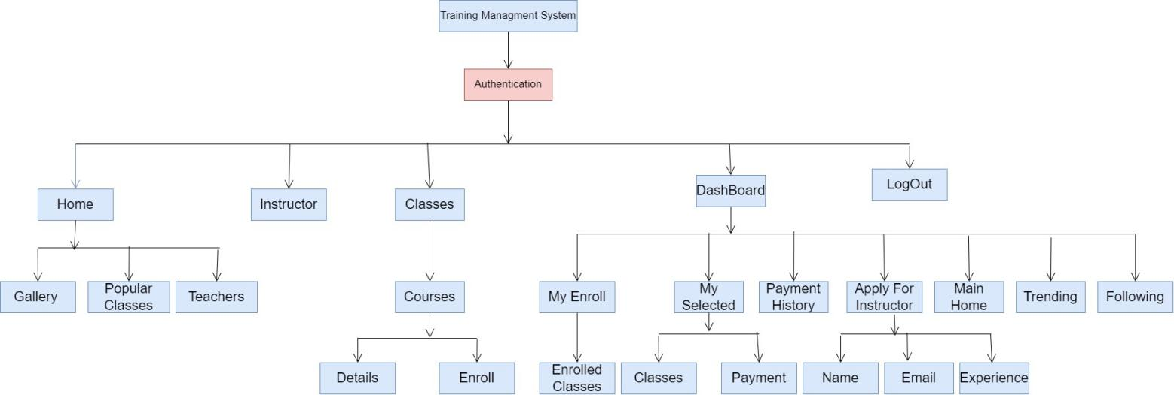

Figure 4.1 NAVIGATION CHART FOR USER

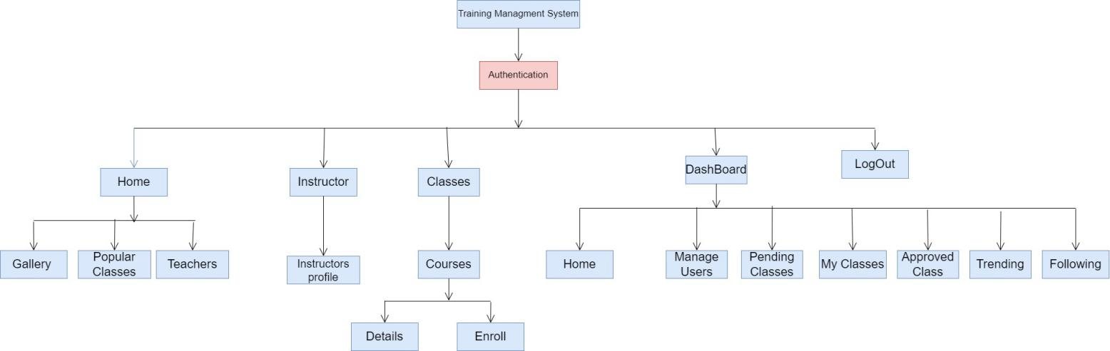

Figure 4.2 NAVIGATION CHART FOR ADMIN

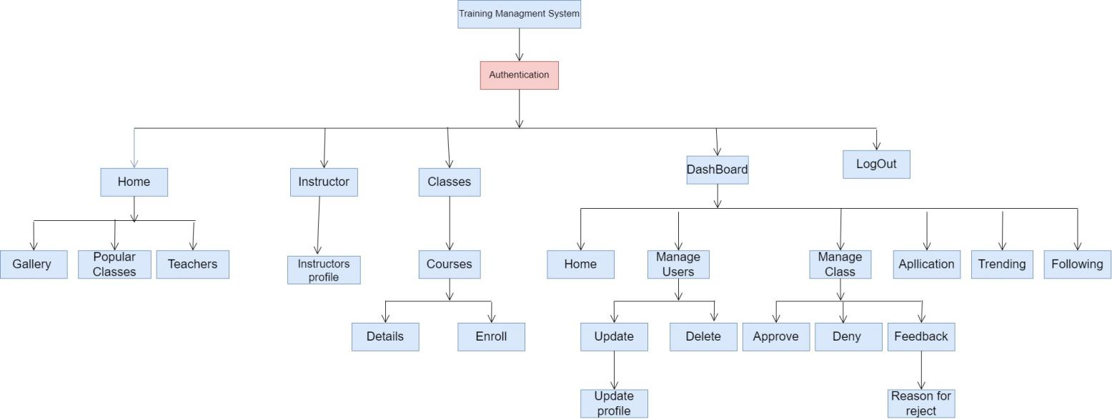

Figure 4.3 NAVIGATION CHART FOR INSTRUCTOR

## SYSTEM ACTIVITY

The system activity of a music recommendation system encompasses the various processes and interactions that occur within the system to provide personalized music recommendations to users. Here's an overview of the system activity in a typical music recommendation system:

**Data Collection:**

User Interaction Logging: The system collects data on user interactions with the platform, including song plays, likes, skips, searches, and user profiles.

Music Metadata Acquisition: Retrieves metadata about songs, albums, artists, genres, and other relevant information from external sources such as music databases or APIs (e.g., Spotify, Last.fm).

Social Media Integration: Optionally, the system may integrate with social media platforms to gather additional user preferences or music-related activities.

**Data Processing:**

Feature Extraction: Extracts relevant features from the collected data, such as user preferences, song characteristics (e.g., genre, tempo, mood), and contextual information (e.g., time of day, location).

Data Cleaning and Transformation: Preprocesses and cleans the collected data to handle missing values, outliers, and inconsistencies.

Data Integration: Integrates various data sources and formats to create a unified dataset for analysis.

**Machine Learning Model Training:**

Model Selection: Chooses appropriate machine learning algorithms or models for recommendation generation, such as collaborative filtering, content-based filtering, or hybrid approaches.

Training Data Preparation: Prepares training data by splitting datasets into training, validation, and testing sets.

Model Training: Trains machine learning models using historical user interactions and music features to learn patterns and preferences.

Model Evaluation: Evaluates the trained models' performance using metrics like accuracy, precision, recall, and ranking metrics.

**Recommendation Generation:**

Personalized Recommendation Generation: Generates personalized music recommendations for users based on their historical interactions, preferences, and contextual information.

Diversification and Serendipity: Optionally, incorporates techniques to diversify recommendations and introduce serendipity to expose users to new and relevant music outside their usual preferences.

Real-Time Recommendations: Provides real-time or near-real-time recommendations based on user interactions and dynamically changing preferences.

**Feedback and Adaptation:**

Feedback Collection: Collects user feedback on recommended songs (e.g., thumbs up/down, ratings, explicit feedback).

Model Adaptation: Incorporates user feedback to update and improve recommendation models through techniques like collaborative filtering updates, retraining, or online learning.

**Delivery and Presentation:**

Presentation Layer: Renders and delivers recommended music content to users through various interfaces, such as web applications, mobile apps, or smart devices.

User Interface Personalization: Personalizes the user interface to enhance user experience, showcasing recommendations prominently and providing intuitive navigation options.

**Monitoring and Maintenance:**

System Monitoring: Monitors system performance, availability, and resource usage to ensure smooth operation.

Error Handling and Logging: Handles errors gracefully and logs relevant information for troubleshooting and debugging.

Regular Maintenance: Conducts regular maintenance tasks such as database cleanup, model retraining, and software updates to ensure system reliability and performance.

By understanding and analyzing these system activities, developers and stakeholders can optimize and enhance the performance of the music recommendation system, providing users with high-quality, personalized music recommendations.

## DATA MODELING

### **Data Dictionary**

Table 4.1 USERS DATA

|  |  |  |
| --- | --- | --- |
| **Column** | **DataType** | **FieldType** |
| **Name** | String | text |
| **Email** | String | text |
| **PhotoURL** | String | text |
| **Gender** | String | select |
| **Address** | String | text |
| **Role** | String | select |
| **Phone No.** | Integer | text |

Table 4.2 CLASSES DATA

|  |  |  |
| --- | --- | --- |
| **Column** | **DataType** | **FieldType** |
| **Name** | String | text |
| **Image** | String | text |
| **AvailableSeats** | Integer | text |
| **Price** | Integer | text |
| **VideoLink** | String | text |
| **Description** | String | text |
| **InstructorName** | String | text |
| **InstructorEmail** | String | text |
| **Status** | String | default |
| **Submitted** | String | button |
| **TotalEnrolled** | Integer | text |
| **Reason** | String | text |

Table 4.3 Cart Data

|  |  |  |
| --- | --- | --- |
| **Column** | **DataType** | **FieldType** |
| **Name** | String | text |
| **ClassID** | Integer | none |
| **Email** | String | text |

Table 4.4 Applied Data

|  |  |  |
| --- | --- | --- |
| **Column** | **DataType** | **FieldType** |
| **Name** | String | text |
| **Email** | String | text |
| **Experience** | String | text |

### **ER Diagram**

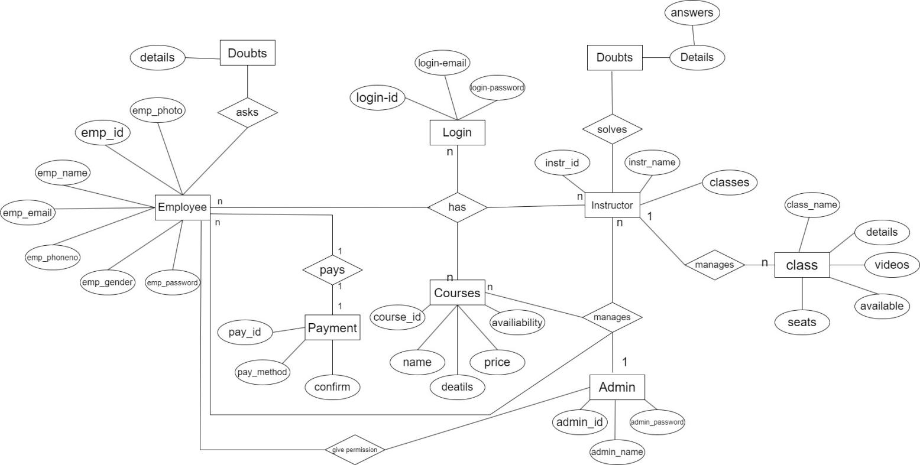

Figure 4.4 ER Diagram

# **SYSTEM DESIGN**

## SYSTEM ARCHITECTURE DESIGN

### **Class Diagram**

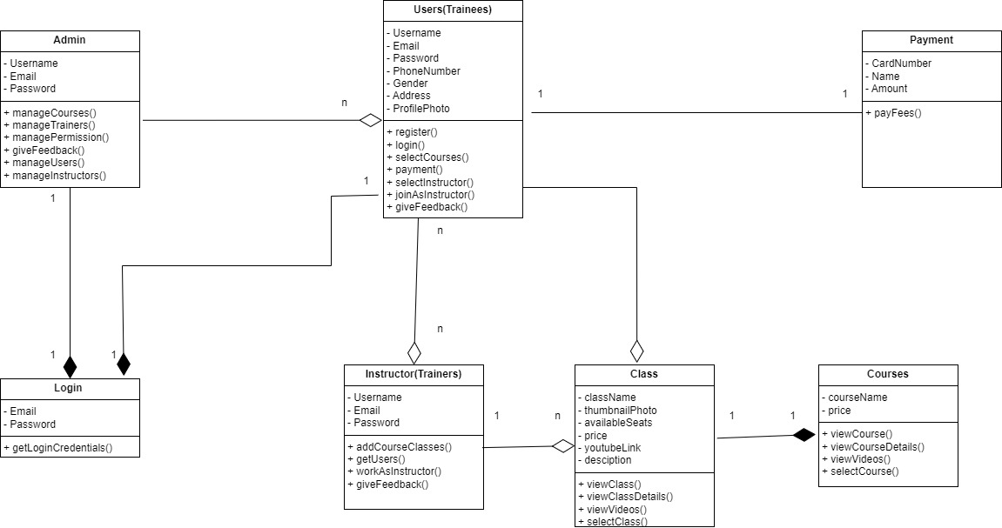

Figure 5.1 CLASS DIAGRAM

### **Sequence Diagram**

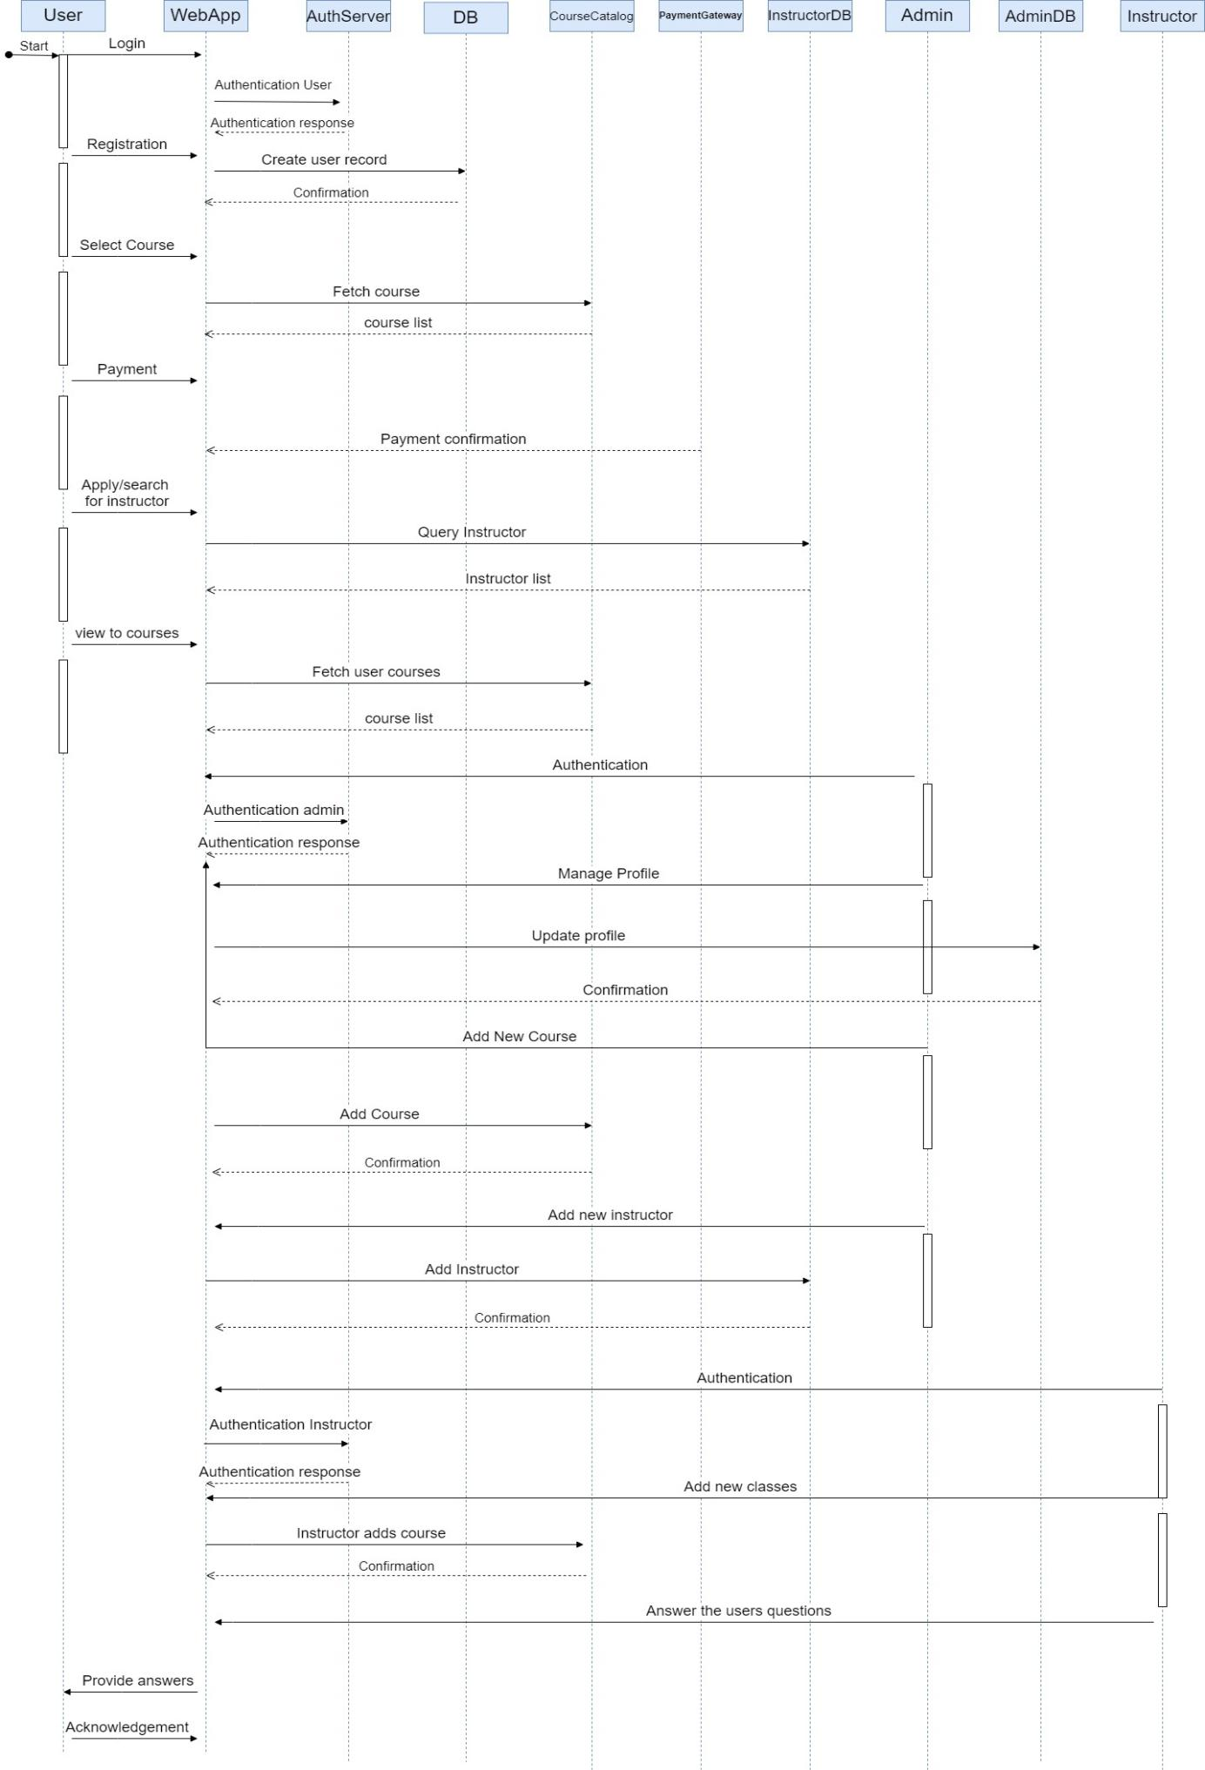

Figure 5.2 SEQUENCE DIAGRAM

### **Component Diagram**

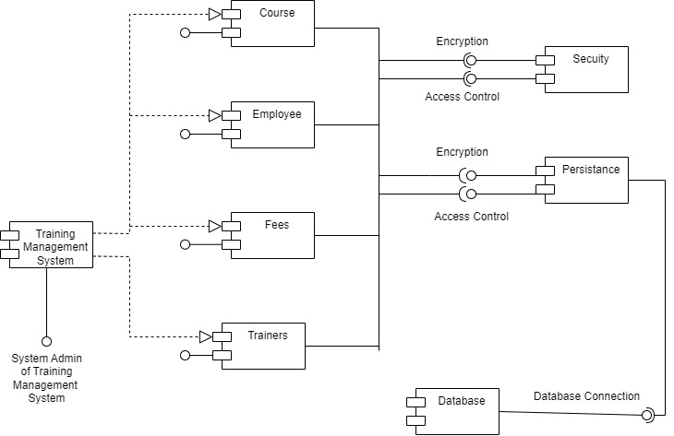

Figure 5.3 COMPONENT DIAGRAM

### **Deployment Diagram**

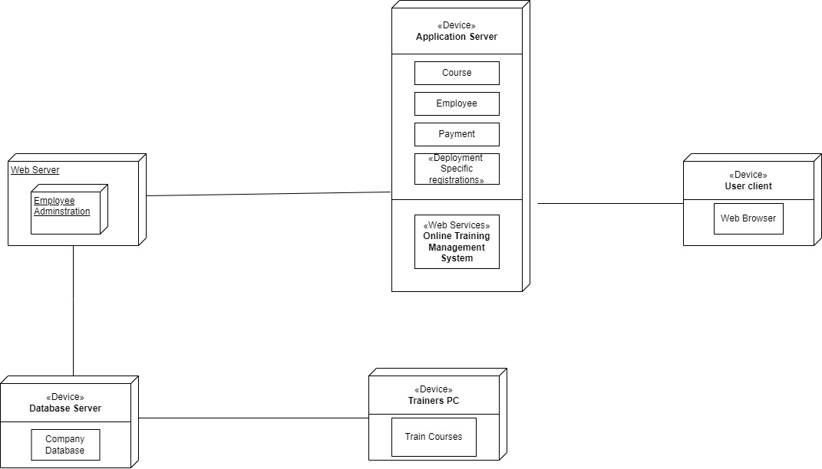

Figure 5.4 DEPLOYMENT DIAGRAM

## USECASE DIAGRAM

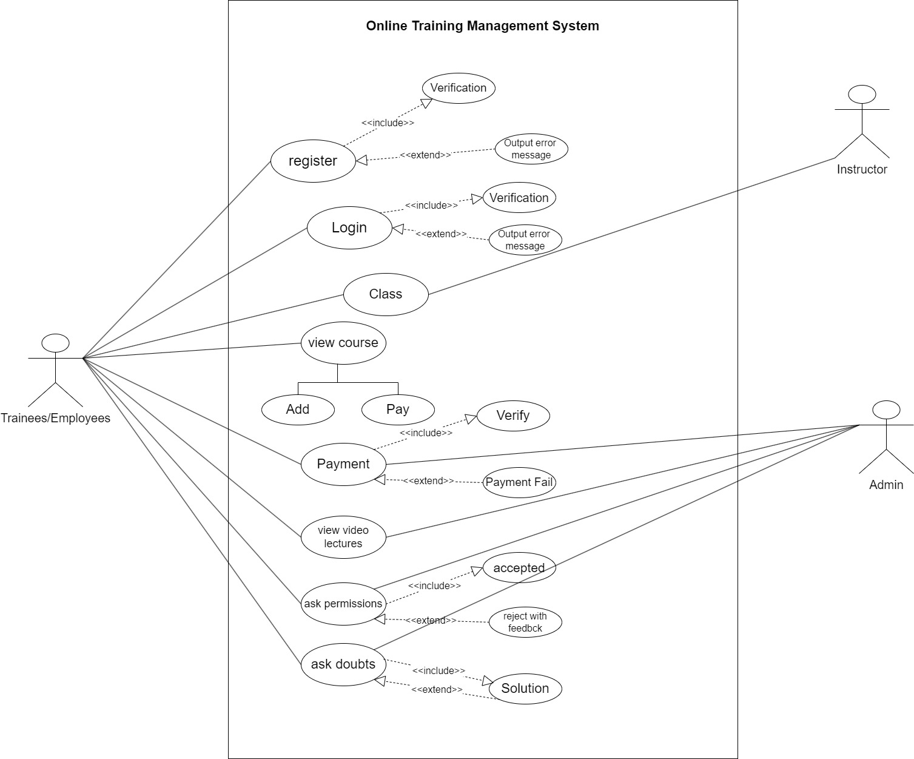

Figure 5.5 USECASE DIAGRAM

## ACTIVITY DIAGRAM

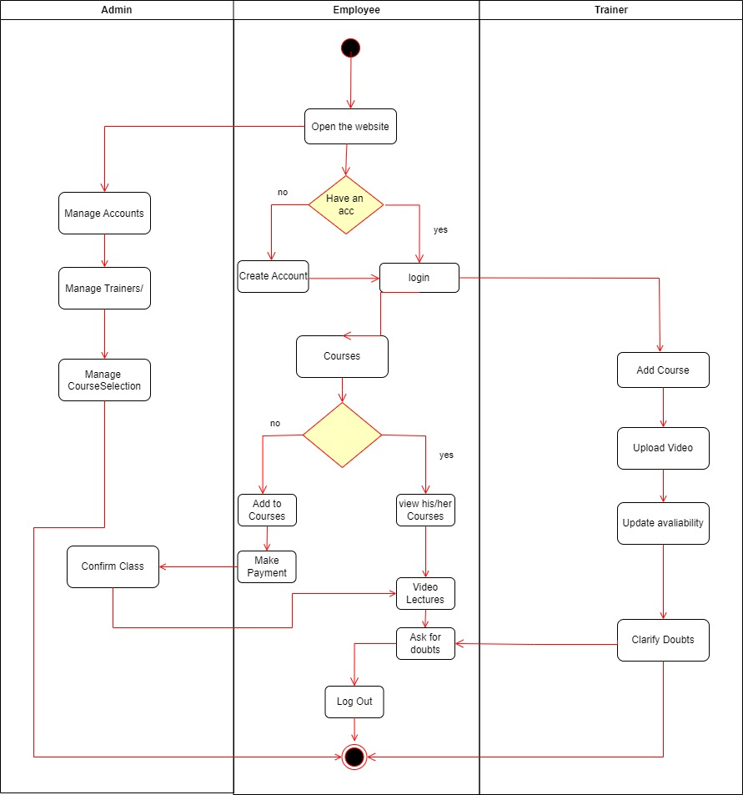

Figure 5.6 ACTIVITY DIAGRAM

## DATA FLOW DIAGRAM

### **Level-0 (Context level)**

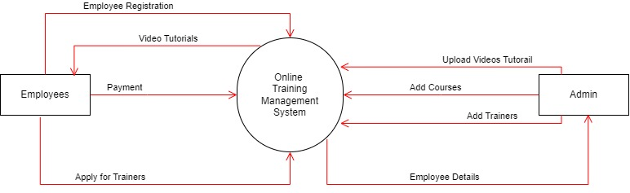

Figure 5.7 DFD LEVEL-0

### **Level-1 (Context level)**

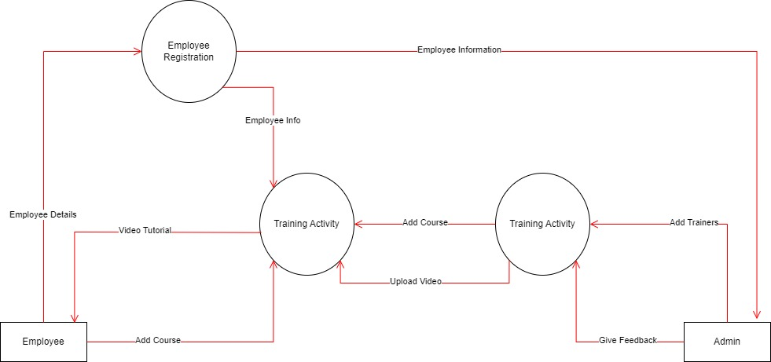

Figure 5.8 DFD LEVEL-1

### **Level-2 (Context level)**

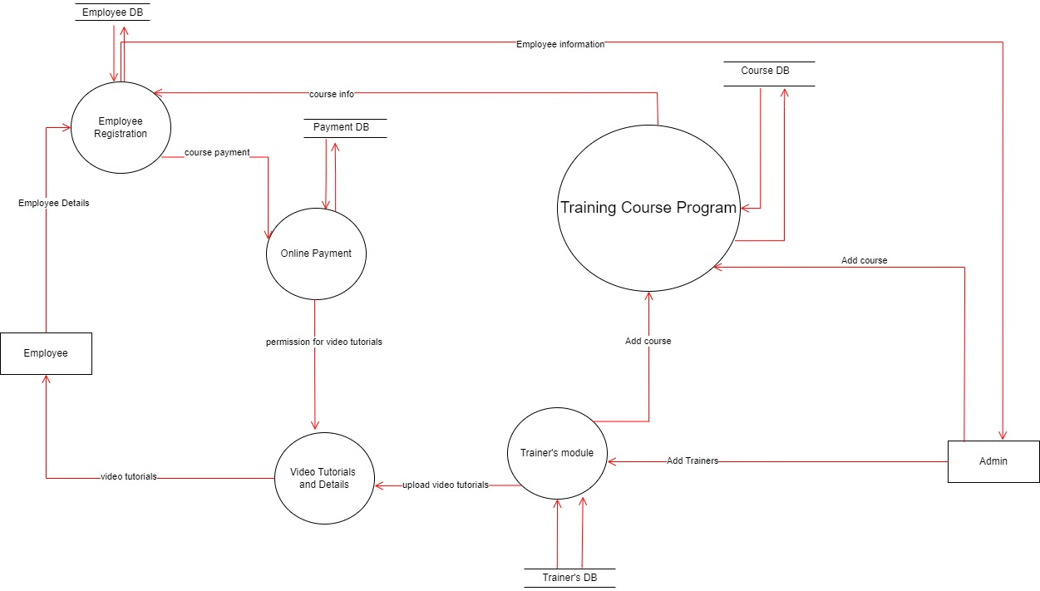

Figure 5.9 DFD LEVEL-2

## STATECHART DIAGRAM

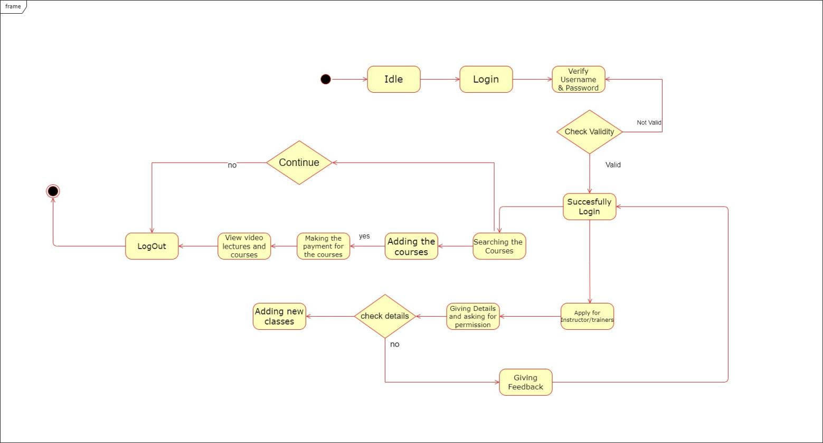

Figure 5.10 STATECHART DIAGRAM

# **IMPLEMENTATION PLANNING**

## IMPLEMENTATION ENVIRONMENT

In implementing the Online Training Management System (TMS), the environment comprises key components: hardware infrastructure, software stack, network setup, integration with external systems, development/testing environment, and deployment/maintenance protocols. This involves selecting appropriate server hardware and software, ensuring reliable network infrastructure, integrating with existing systems, setting up development/testing environments, and deploying the system securely to production. Through careful planning and configuration, organizations can ensure a robust environment that supports efficient training management while maintaining reliability, security, and scalability.

## PROGRAM/MODULES SPECIFICATION

Our entire system we have 8 modules.

1. User Authentication Module:

• Responsible for user login and authentication to access the system securely.

• Verifies user credentials and grants appropriate access levels based on user roles.

2. Administrator Dashboard Module:

• Provides administrators with a centralized interface to manage user accounts, course catalog, and system configurations.

• Allows administrators to create, edit, and delete user accounts, manage course schedules, and generate reports on training activities.

3. Course Management Module:

• Enables instructors to create and manage course content, including lectures, assignments, and assessments.

• Allows instructors to schedule classes, enroll trainees, and track their progress throughout the course.

4. Trainee Interface Module:

• Offers trainees an intuitive interface to browse and enroll in available courses, access training materials, and complete assignments.

• Allows trainees to track their learning progress and receive feedback from instructors.

5. Communication Module:

• Facilitates communication between users through features like messaging, discussion forums, and announcements.

• Enhances collaboration and engagement among administrators, instructors, and trainees within the TMS platform.

6. Reporting and Analytics Module:

• Provides comprehensive reporting and analytics tools to track training activities, assess user performance, and evaluate the effectiveness of courses.

• Enables administrators and instructors to make data-driven decisions to improve training outcomes.

7. Security and Compliance Module:

• Implements robust security measures to protect user data and ensure compliance with data privacy regulations.

• Manages training compliance and certifications, ensuring adherence to industry standards and regulations.

8. Integration Module:

• Facilitates integration with external systems such as Human Resources Information Systems (HRIS) and Learning Management Systems (LMS) to streamline data exchange and enhance functionality.

• Implements standardized APIs and protocols for seamless integration with third-party applications and services.

By specifying these modules, the TMS can provide a comprehensive and tailored solution for efficient training management, meeting the diverse needs of users while ensuring security, compliance, and scalability.

## CODING STANDARDS

While writing our code we took the utmost care to follow the basic coding standards while writing a code like,

* Doing proper indentation.
* Following proper indentation.
* Proper error handling.
* Adding comments for better understanding.
* Proper Syntax

Here are some of the code snippets written during implementation,

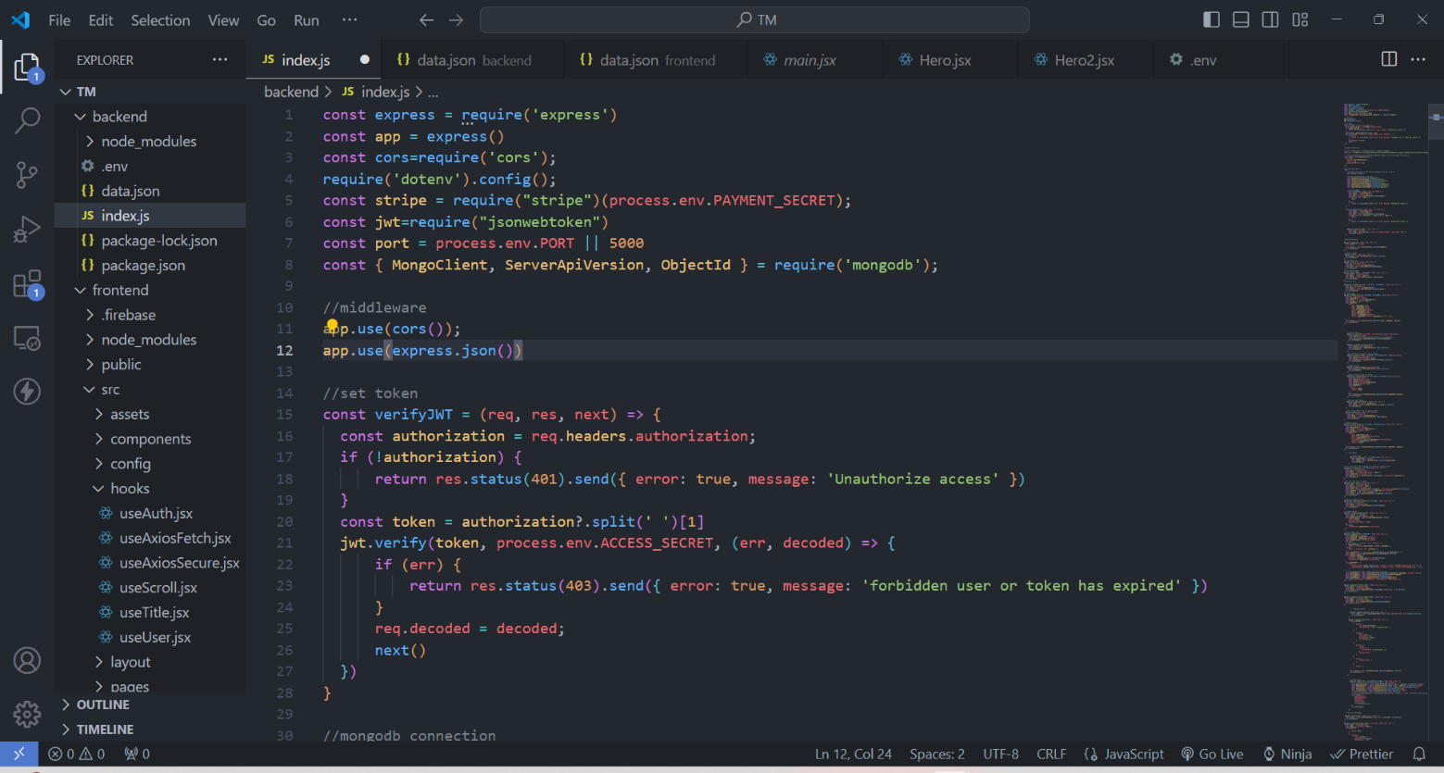

Figure 6.1 Index.js

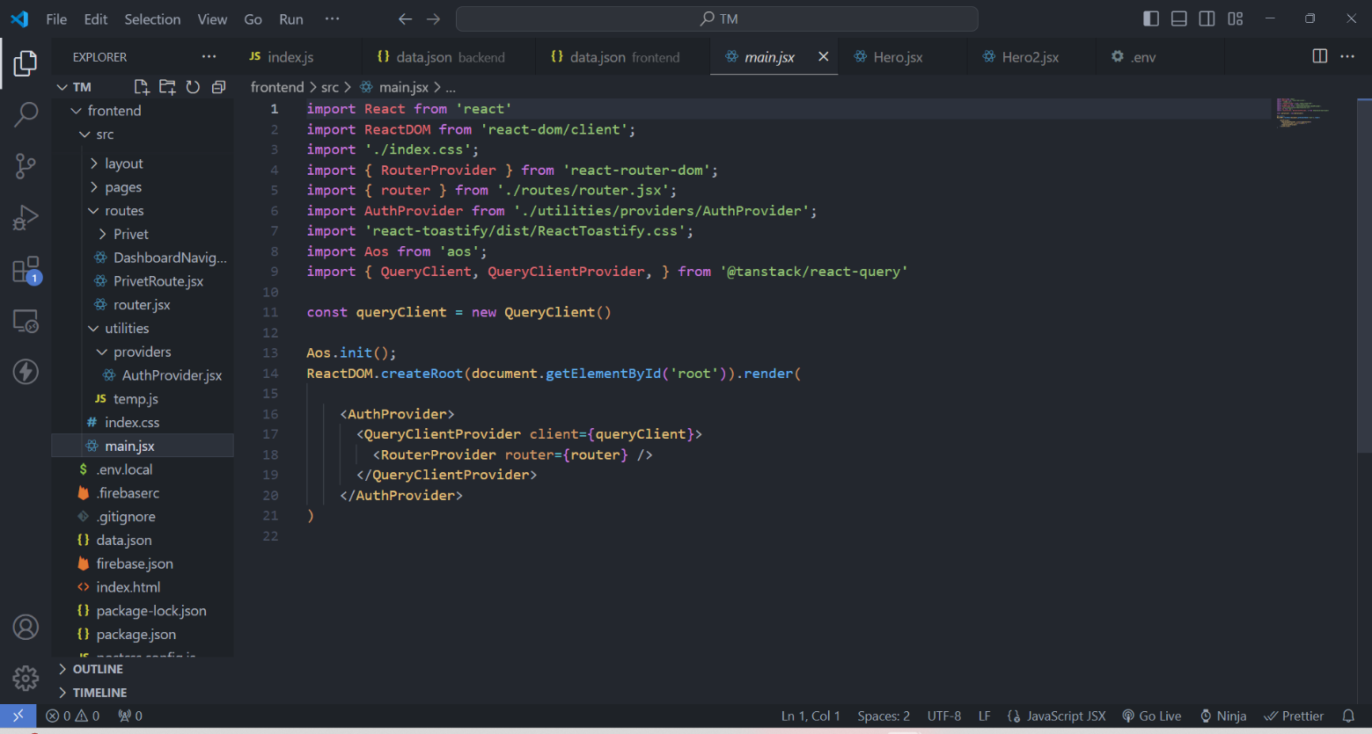

Figure 6.2 main.jsx

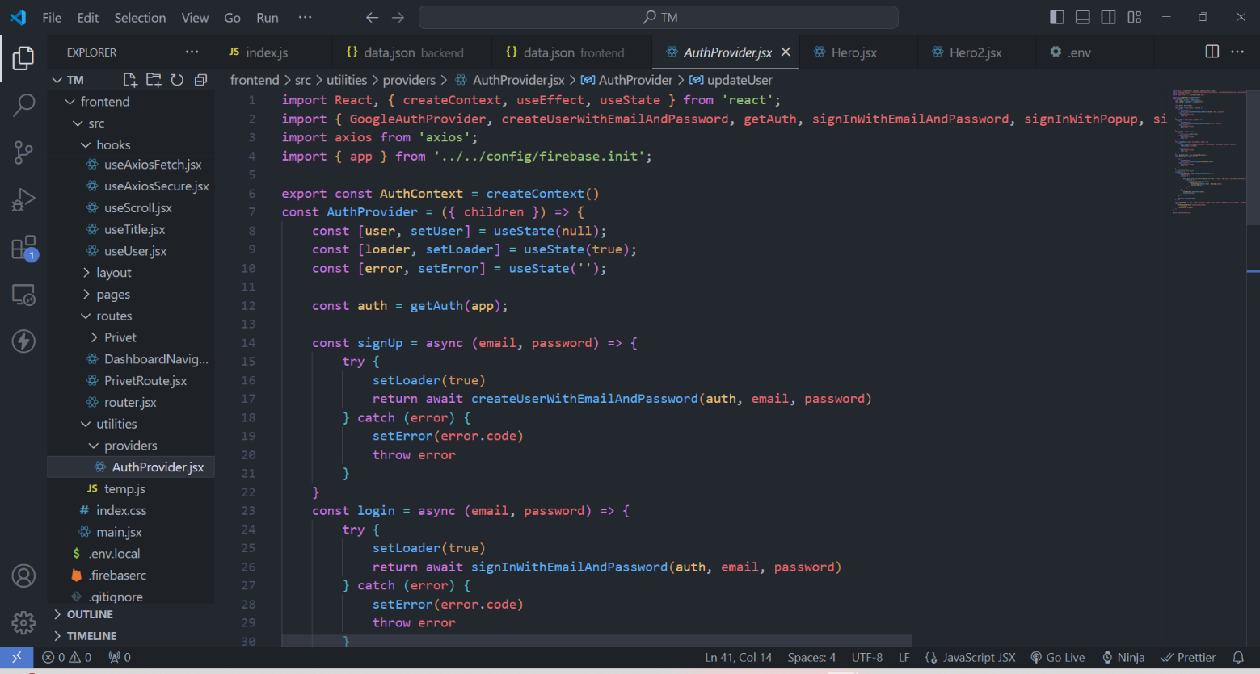

Figure 6.3 AuthProvider.jsx

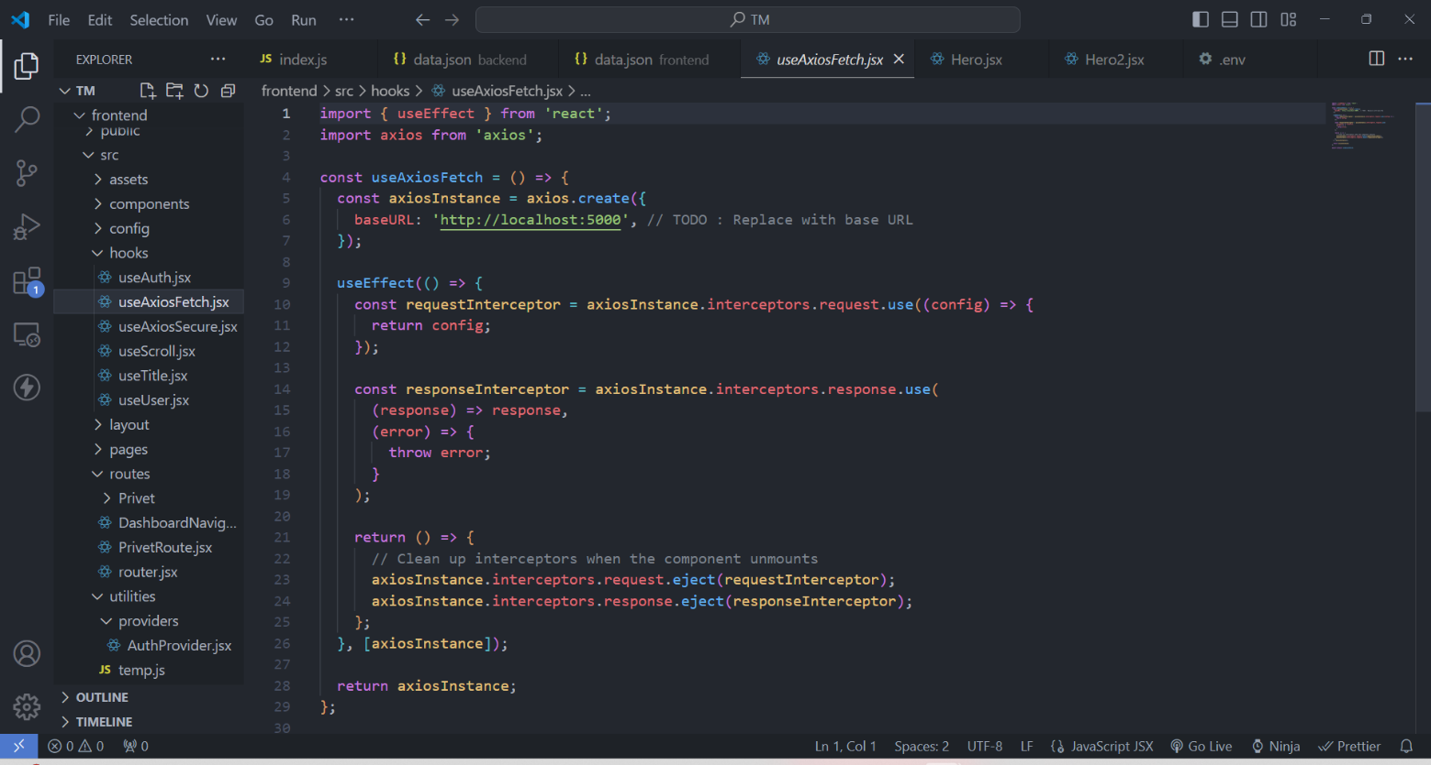

Figure 6.4 useAxiosFetch..jsx

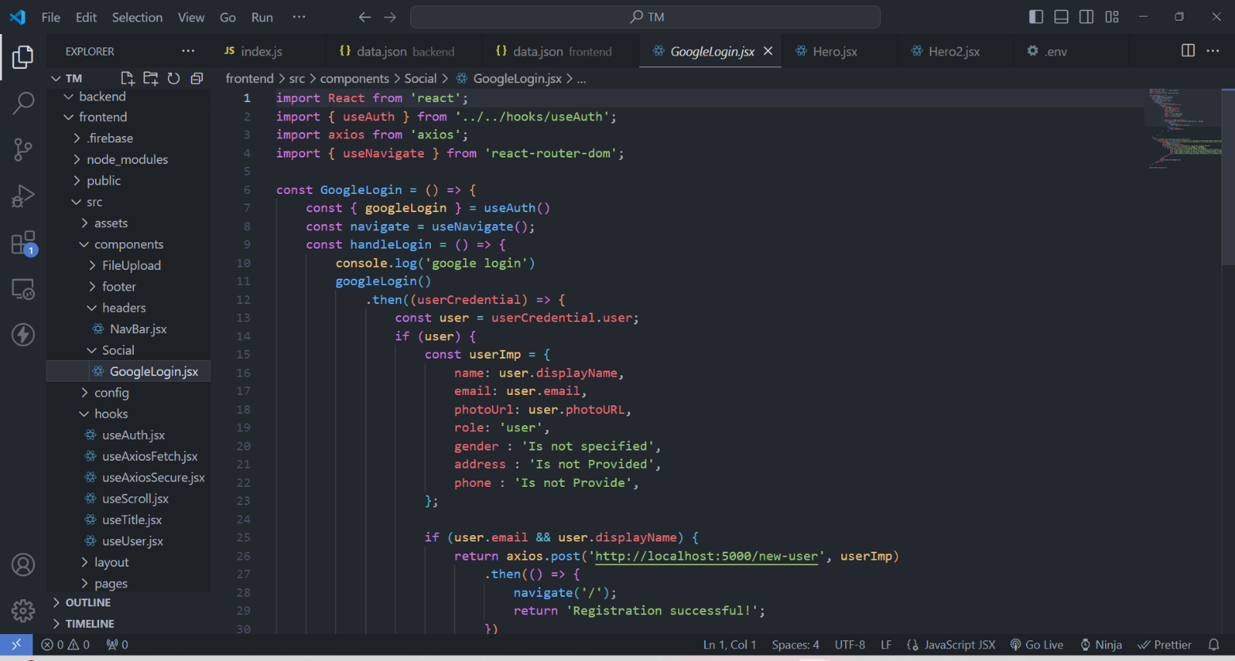

Figure6.5 GoogleLogin.jsx

# **TESTING**

## TESTING PLAN

The testing plan outlines the testing strategy and procedures to ensure the quality, functionality, and reliability of the Online Training Management System (TMS).

**Testing Phases:**

1. **Unit Testing:**

* Test individual modules and components of the TMS in isolation to verify their functionality and behavior.
* Validate input/output mechanisms, data processing logic, and error handling procedures within each module.
* Use automated testing tools and frameworks to streamline testing processes and identify potential defects.

2. **Integration Testing:**

* Validate interactions and data flow between different modules and components of the TMS.
* Verify seamless integration with external systems and services, including HRIS, LMS, and third-party APIs.
* Conduct end-to-end testing scenarios to ensure smooth operation and functionality across interconnected modules.

3. **System Testing:**

* Validate the overall functionality and performance of the TMS as a cohesive system.
* Test core features and user workflows, including user authentication, course enrollment, content access, and reporting capabilities.
* Verify system responsiveness, scalability, and reliability under normal and peak load conditions.

4. **User Acceptance Testing (UAT):**

* Engage end-users, including administrators, instructors, and trainees, to validate the system's usability and effectiveness.
* Solicit feedback on user interface design, navigation, and overall user experience.
* Ensure alignment with user requirements and expectations through real-world testing scenarios and simulations.

The testing plan aims to ensure the Online Training Management System meets quality standards, performs optimally, and delivers a seamless user experience. By following structured testing procedures and leveraging

appropriate tools, any issues or deficiencies in the system can be identified and addressed, ensuring the successful deployment and operation of the TMS.

## TESTING STRATEGY

The testing strategy for the Online Training Management System (TMS) encompasses various stages and techniques to ensure the reliability, functionality, and usability of the system. The following testing approaches will be employed:

**Unit Testing:** Individual modules of the TMS will undergo unit testing to validate their functionality in isolation. Test cases will be designed to verify the correctness of module logic, input validation, and error handling.

**Integration Testing:** Integration testing will focus on validating the interactions between different modules of the TMS. Test cases will verify data flow, communication protocols, and compatibility between integrated components.

**System Testing:** Comprehensive system testing will be conducted to evaluate the overall functionality and performance of the TMS.Test scenarios will cover common user interactions, such as user authentication, course management, and reporting.

**User Acceptance Testing (UAT):** UAT will involve real users (administrators, instructors, and trainees) to assess the usability and effectiveness of the TMS.Testers will execute predefined test cases and provide feedback on the user interface, features, and overall user experience.

**Performance Testing:** Performance testing will measure the responsiveness, scalability, and stability of the TMS under various load conditions.Test scenarios will simulate concurrent user interactions to identify performance bottlenecks and optimize system resources.

**Security Testing:** Security testing will focus on identifying vulnerabilities and ensuring the confidentiality, integrity, and availability of user data.Test cases will evaluate authentication mechanisms, data encryption, access controls, and protection against common security threats.

**Regression Testing:** Regression testing will be performed after each system update or modification to ensure that existing functionality remains unaffected.Test suites will include automated tests and manual verification of critical system features to detect regression issues.

**Accessibility Testing:** Accessibility testing will assess the TMS's compliance with accessibility standards to ensure usability for users with disabilities.Test cases will evaluate screen reader compatibility, keyboard navigation, and alternative content presentation.

**Cross-browser and Cross-device Testing:** Cross-browser and cross-device testing will validate the compatibility of the TMS across different web browsers and devices.Test scenarios will verify the consistent rendering and functionality of the TMS on popular browsers and devices.

By following this comprehensive testing strategy, the TMS will undergo rigorous evaluation to ensure its quality, reliability, and usability, thereby delivering a seamless training management experience for users.

## TESTING METHODS

There are two kinds of testing mainly Blackbox and Whitebox testing:

* Black-Box (User-Centric): Imagine yourself as the user. Test the system's functionality from their perspective. Does it take the right inputs (user data, songs) and deliver the expected outputs (relevant recommendations)? This ensures a user-friendly experience.
* White-Box (Code-Centric): Dive into the code. Test individual modules, functions, and algorithms to verify they operate correctly based on their design. This helps identify bugs within the system's inner workings.

## TEST CASES

Table 7.1 TEST CASES

|  |  |  |  |  |
| --- | --- | --- | --- | --- |
| **ENTITY** | **TEST CASE** | **EXPECTED** | **ACTUAL** | **STATUS** |
| **OUTPUT** | **OUTPUT** |
| Login | Validation | Redirect to Home | Redirect to Home | pass |
| Page | Page |
| Add Course | Adding course | Add course in database | Added course in database | Pass |
| Delete Course | Remove data | Remove course from data base | Removed course from data base | Pass |
| Add Course details | Adding data | Update to screen and data base | Updated to screen and in data base | Pass |
| Request for instructor | Making Request | Request sent to admin | Request sent to admin | Pass |
| Edit details | Update data | Updating details in database | Updating details in database | Pass |

# **USER MANUAL**

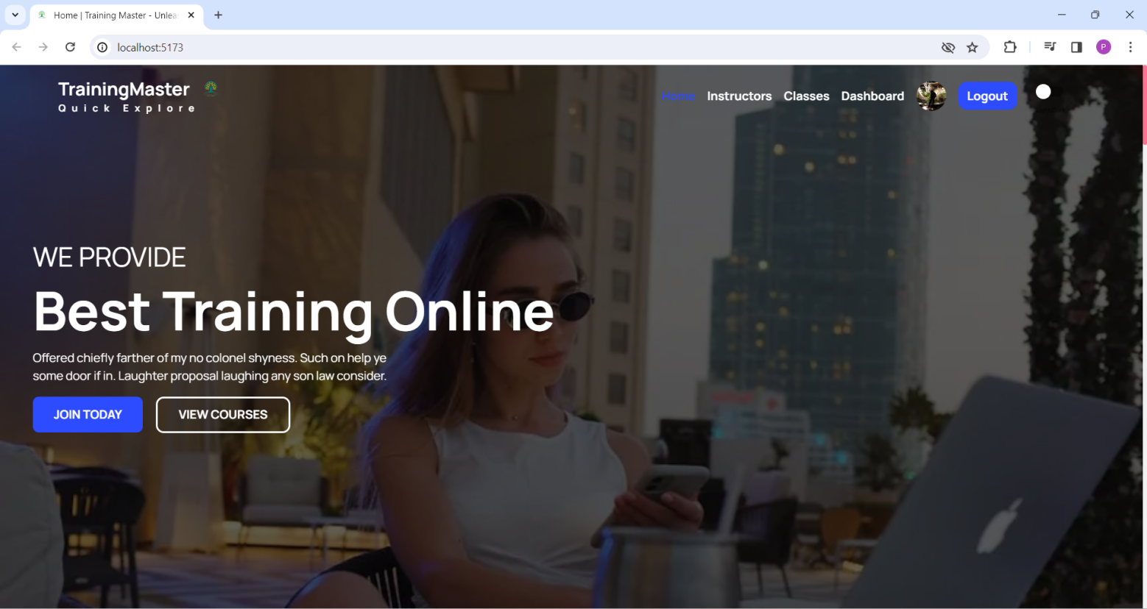

Figure 8.1 HOME PAGE

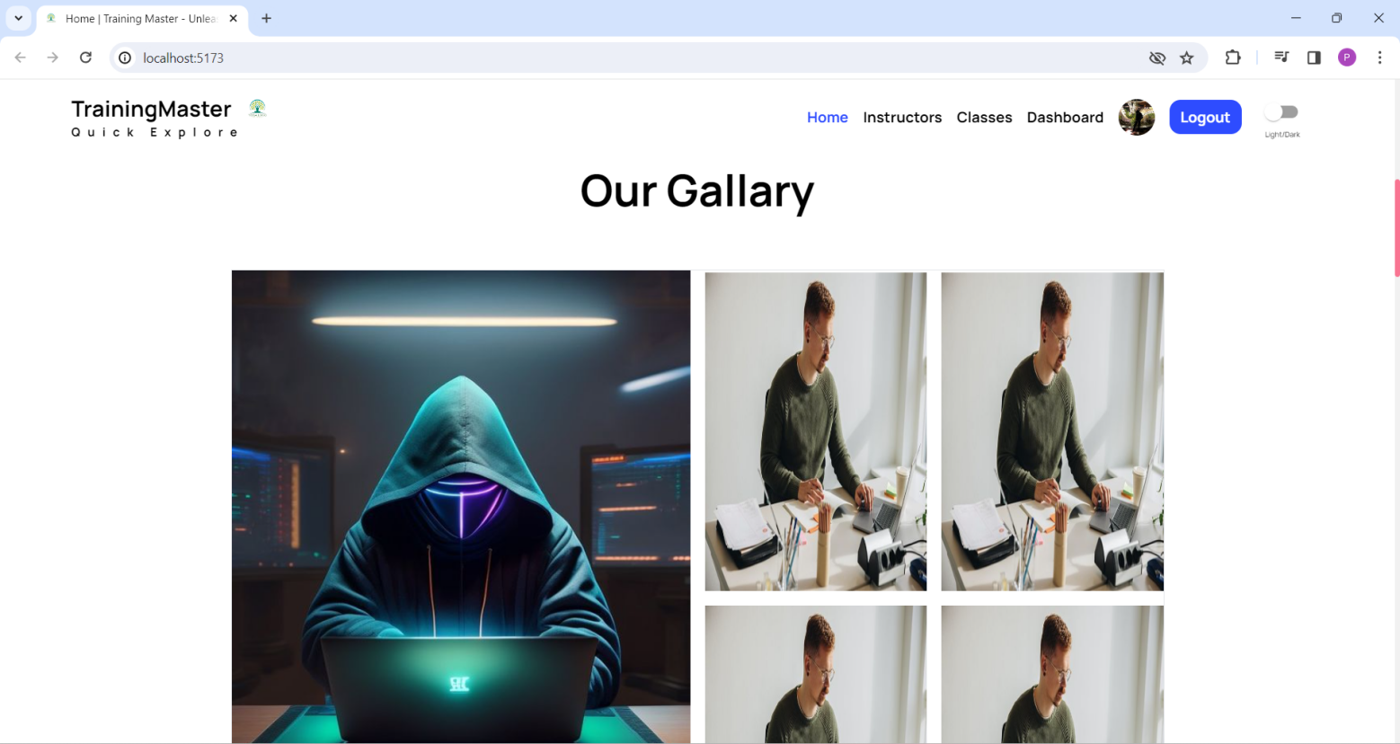

Figure 8.2 OUR GALLARY

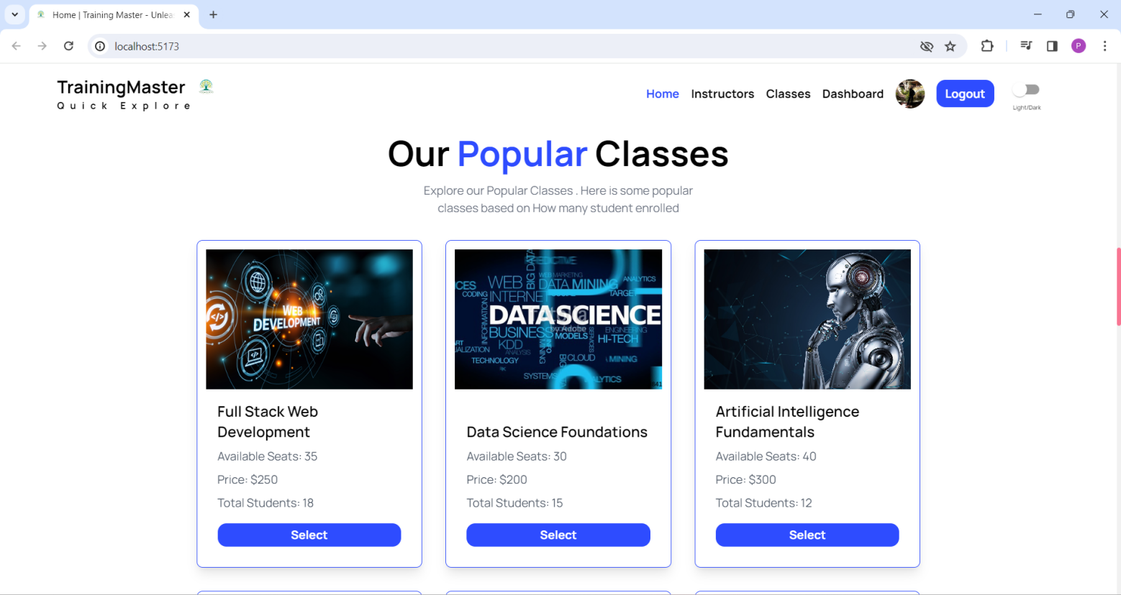

Figure 8.3 POPULAR CLASSES

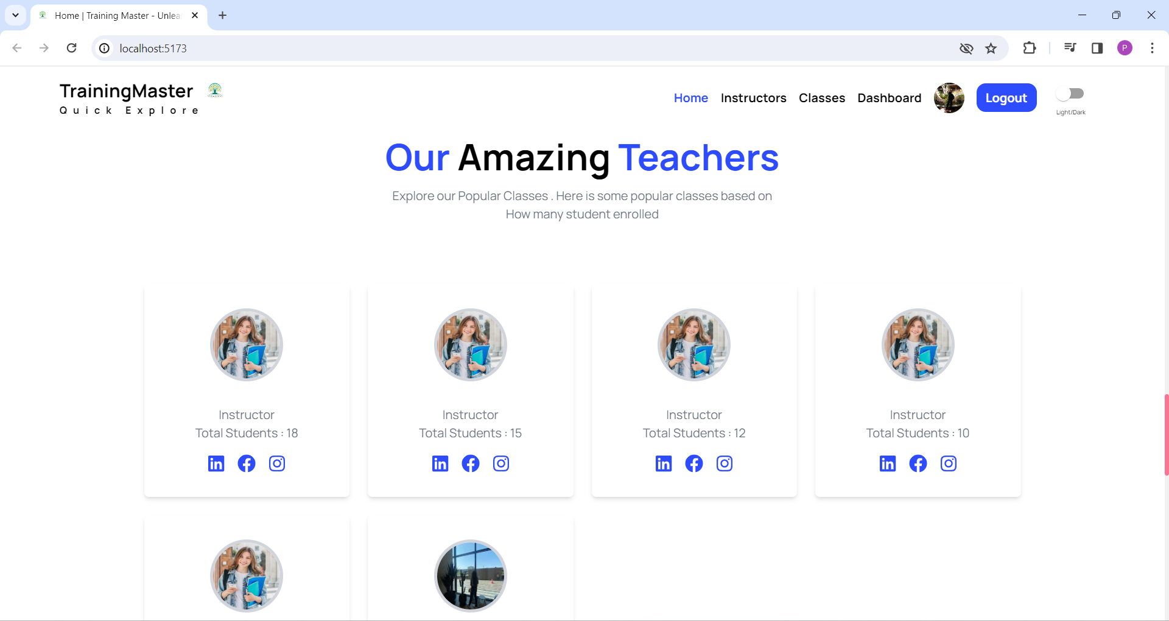

Figure 8.4 TEACHERS

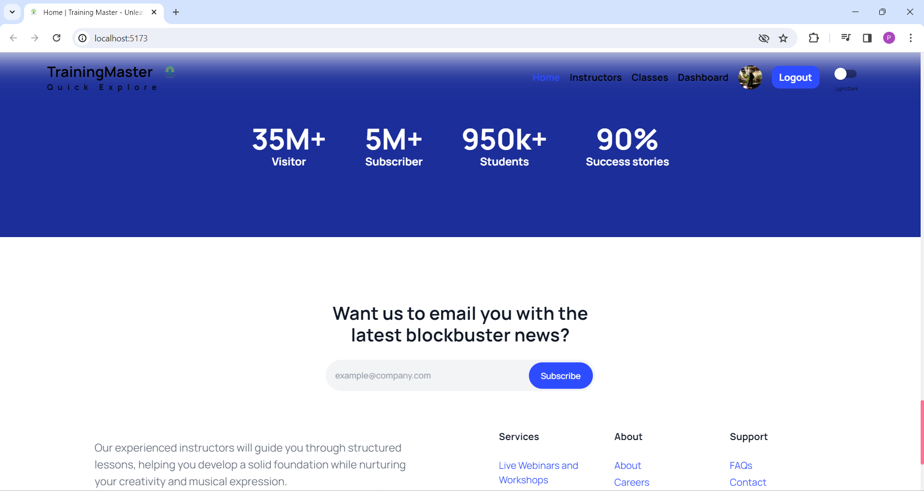

Figure 8.5 NEWSLETTER

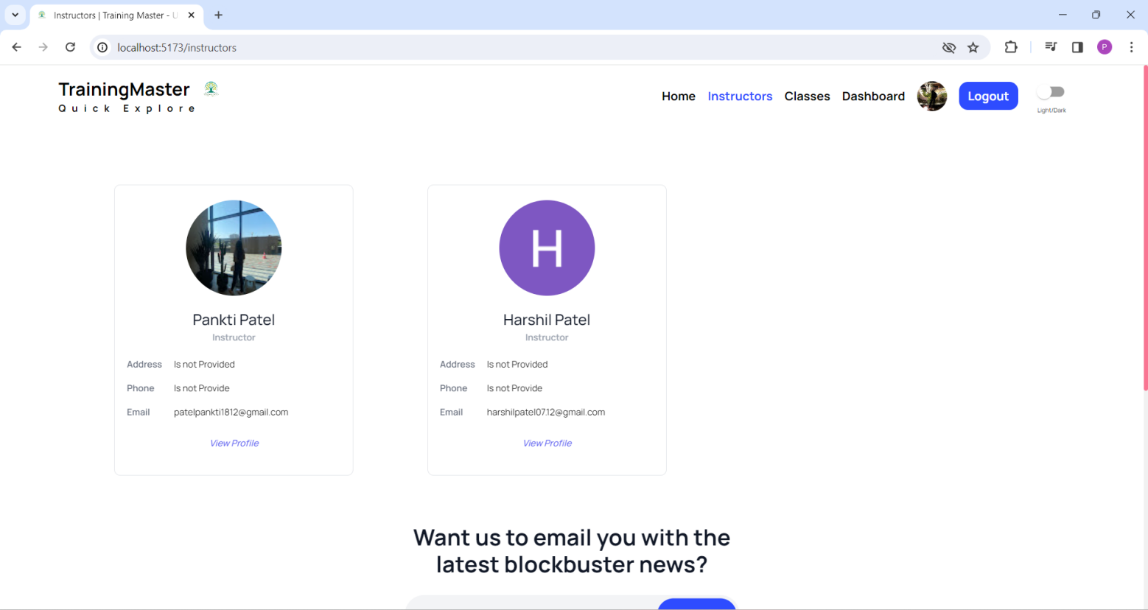

Figure 8.6 INSTRUCTOR PAGE

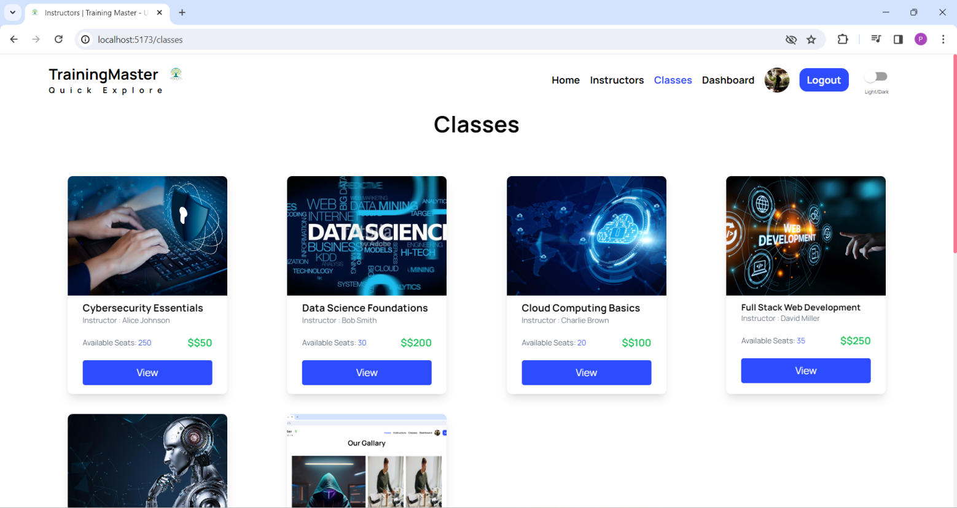

Figure 8.7 CLASSES PAGE

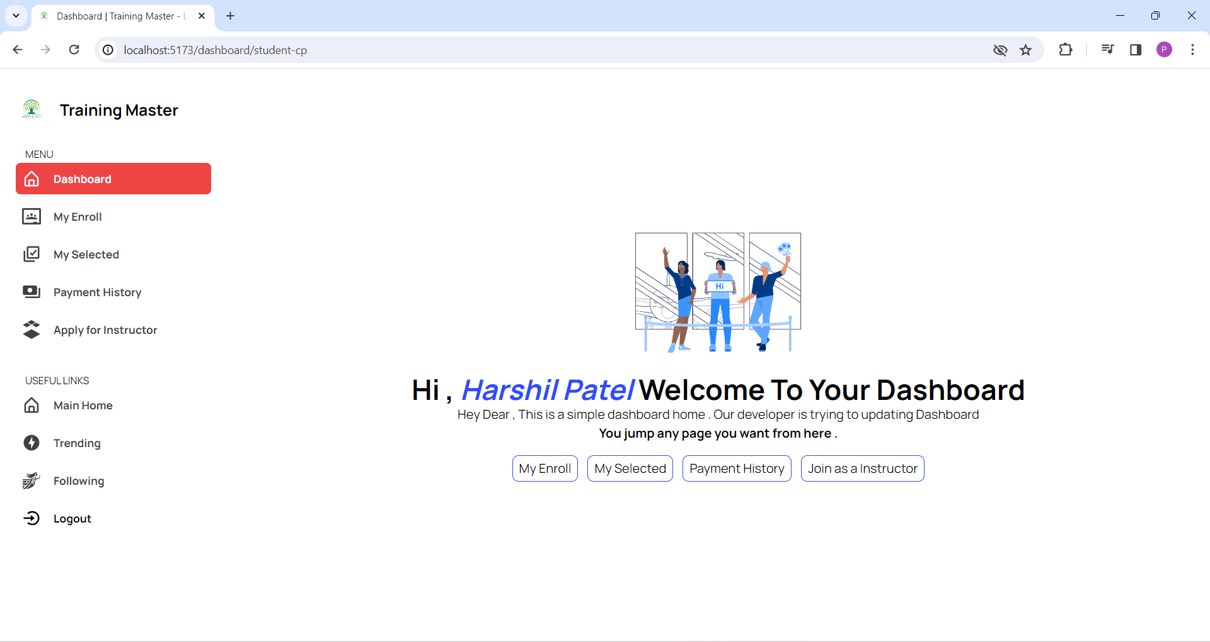

Figure 8.8 USER DASHBOARD

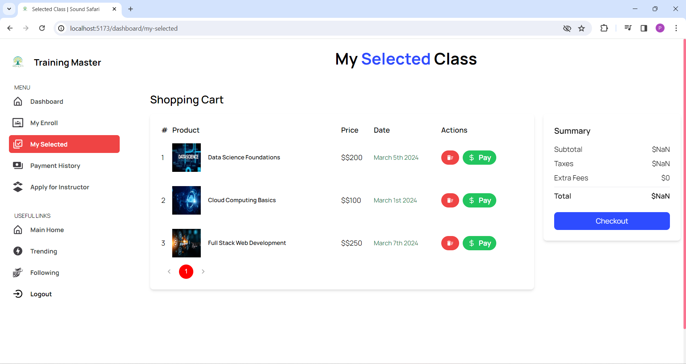

Figure 8.9 SELECTED CLASSES

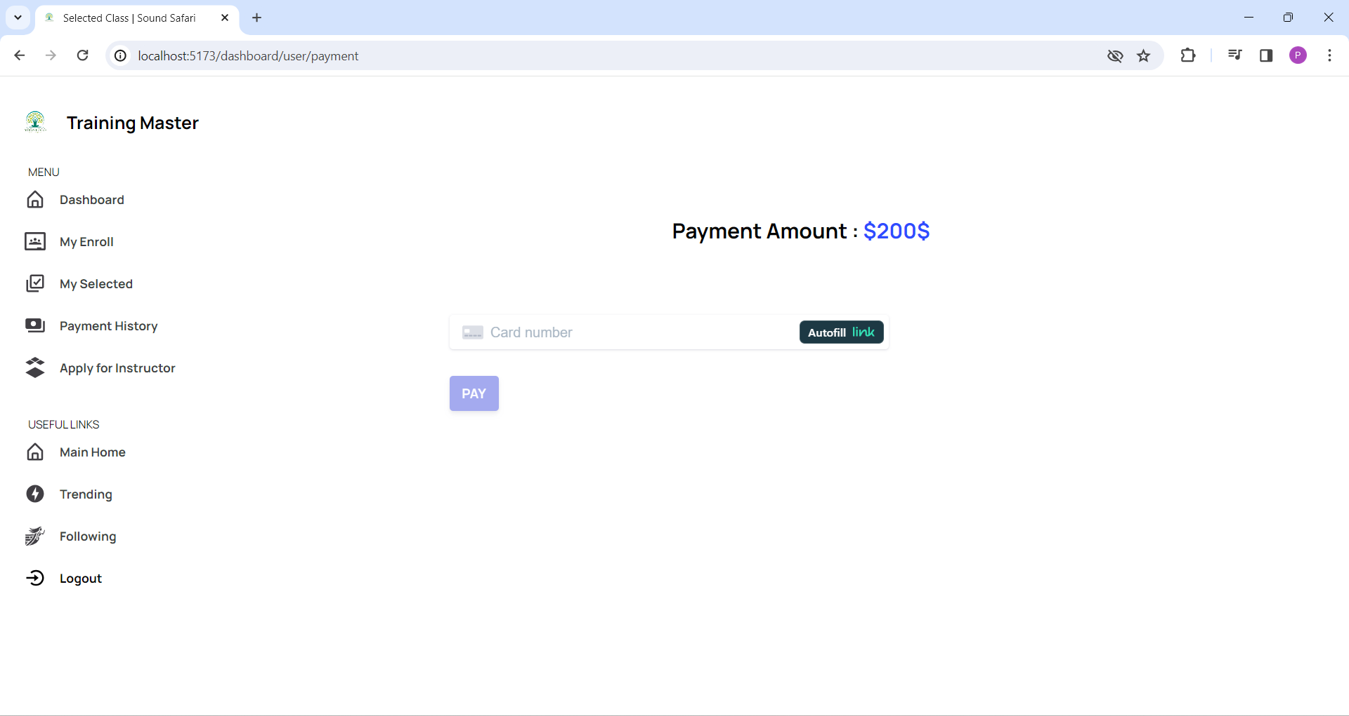

Figure 8.10 PAYMENT MODULE

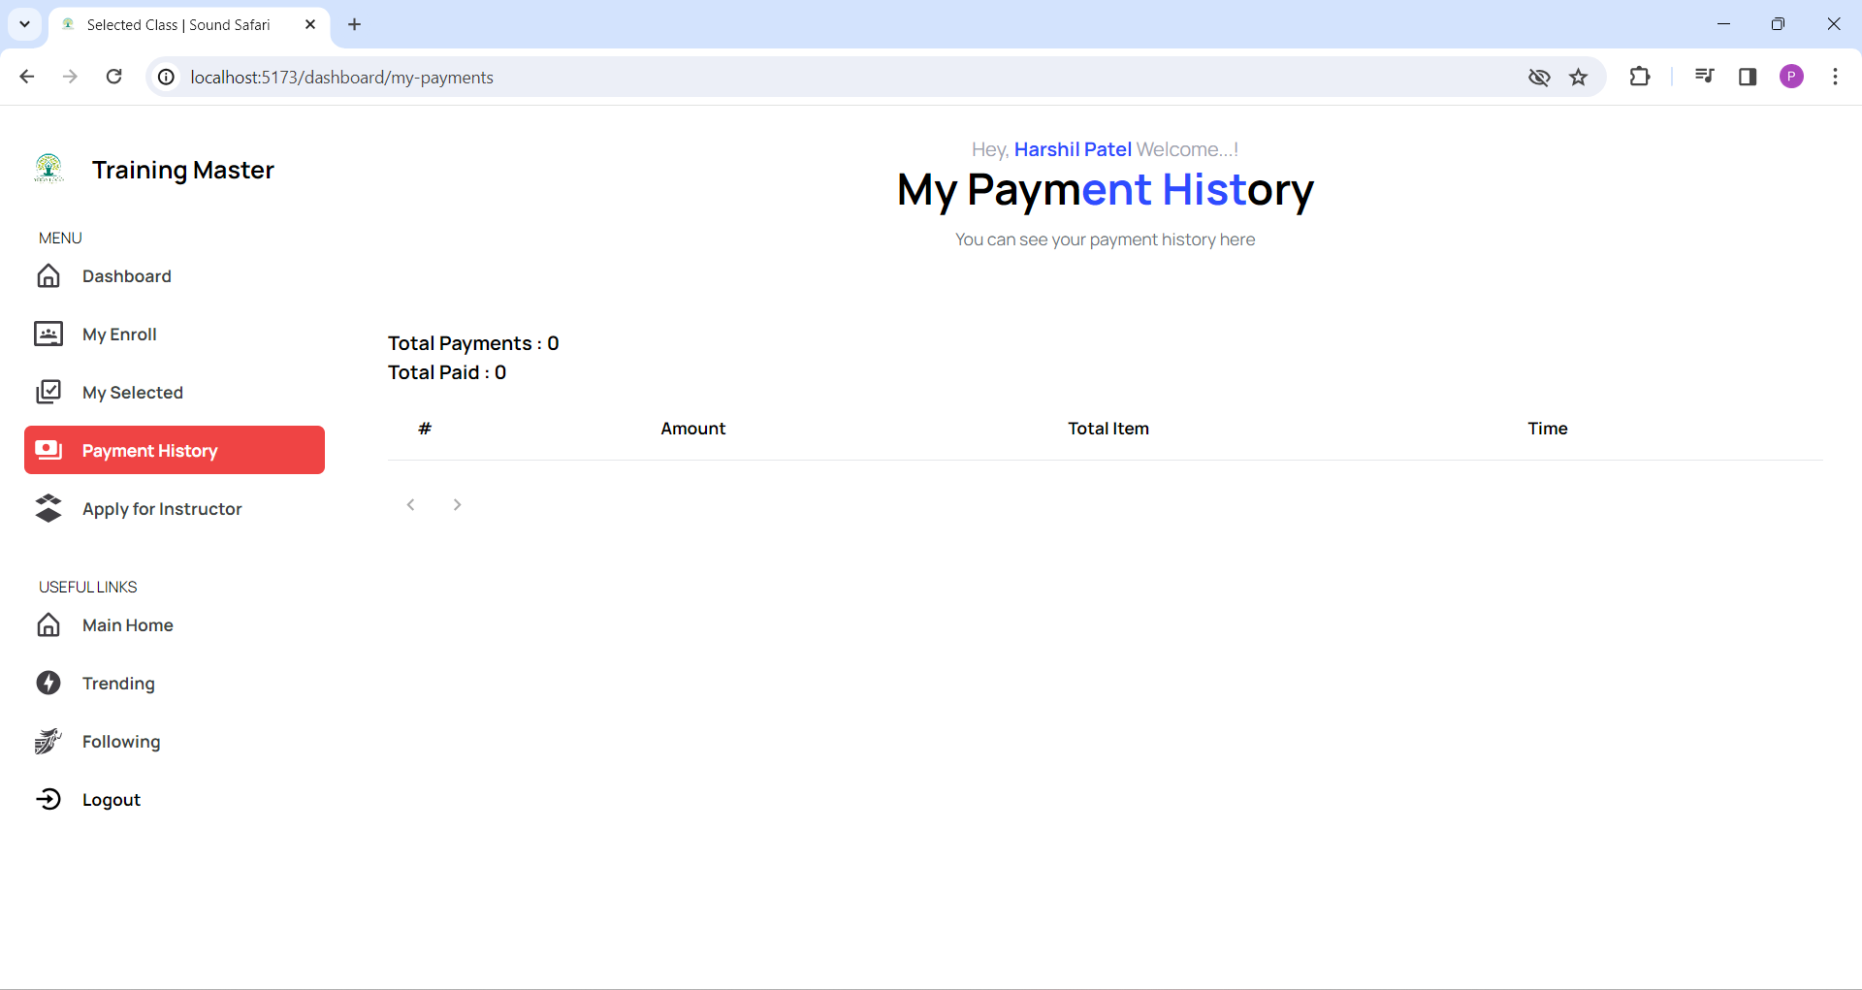

Figure 8.11 PAYMENT HISTORY

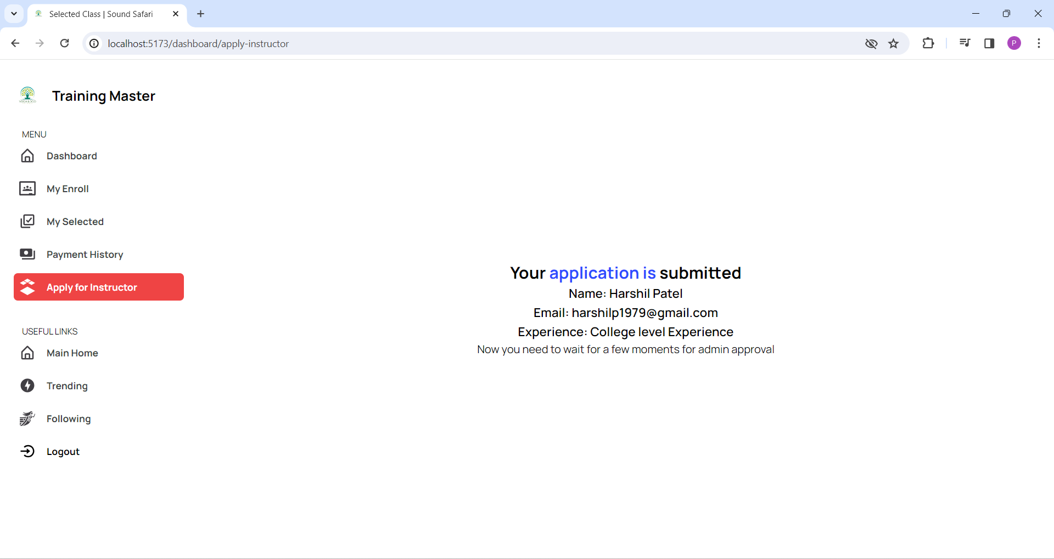

Figure 8.12 APPLICATION FOR INSTRUCTOR

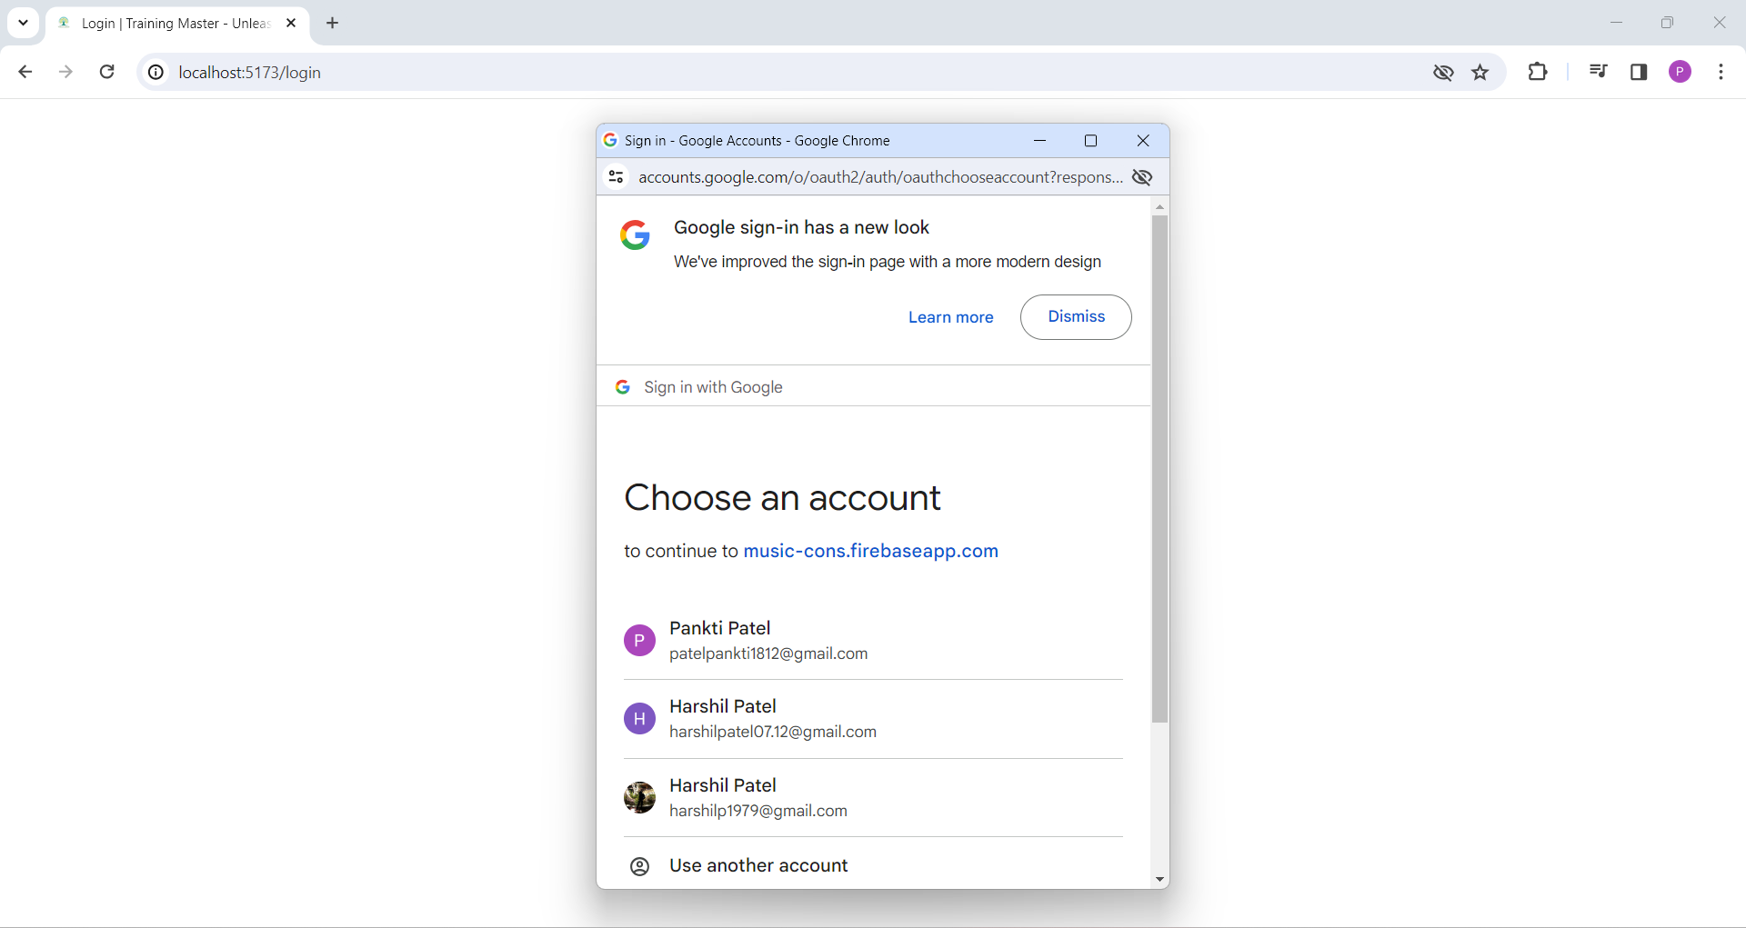

Figure 8.13 SIGN UP PAGE

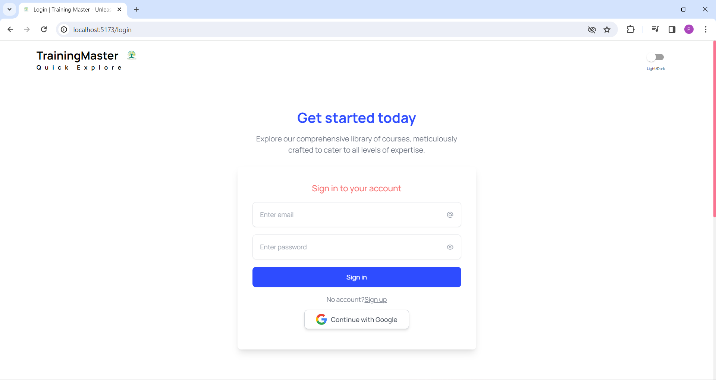

Figure 8.14 SIGN-IN PAGE

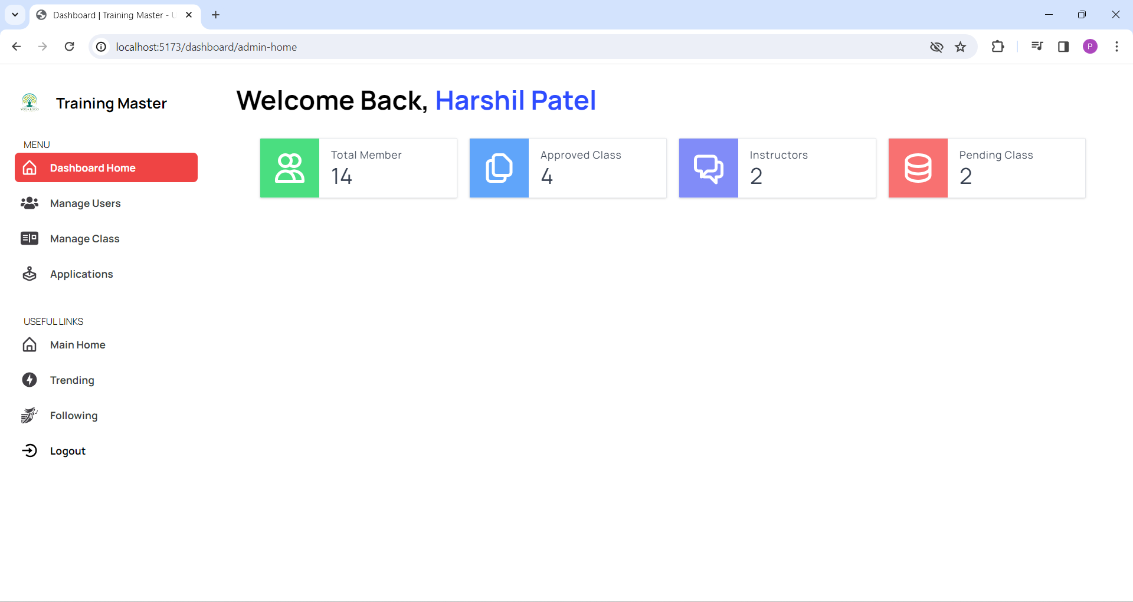

Figure 8.15 ADMIN DASHBOARD

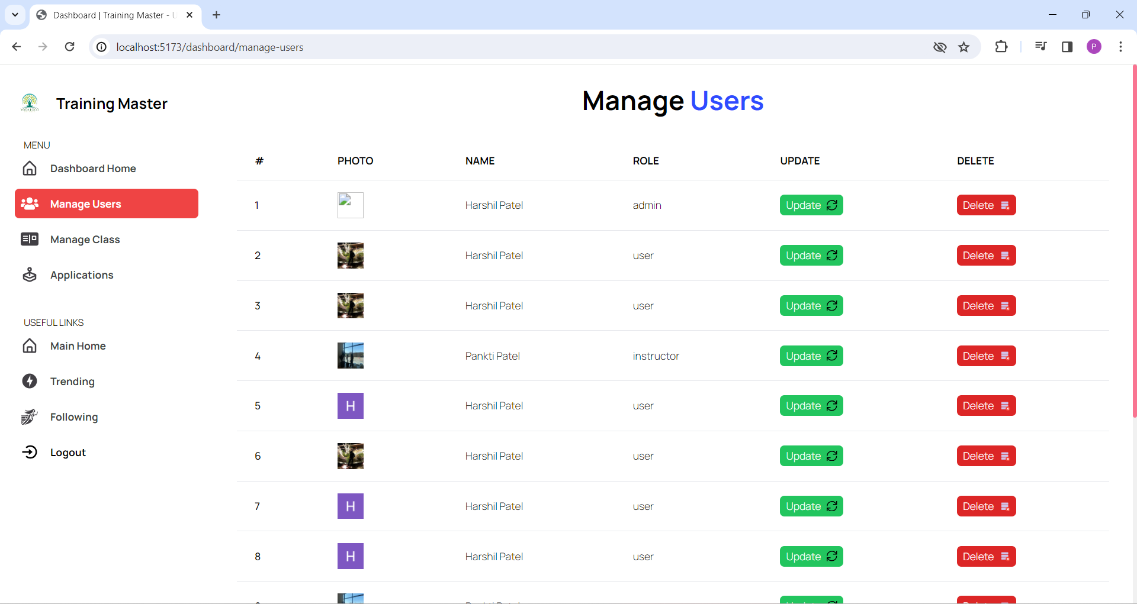

Figure 8.16 MANAGE USERS

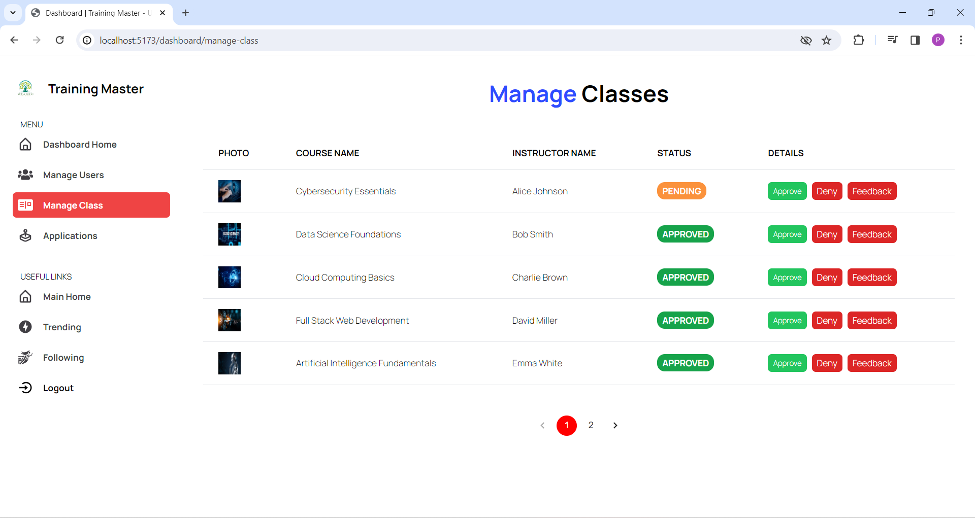

igure 8.17 MANAGE CLASSES-PENDING CLASS

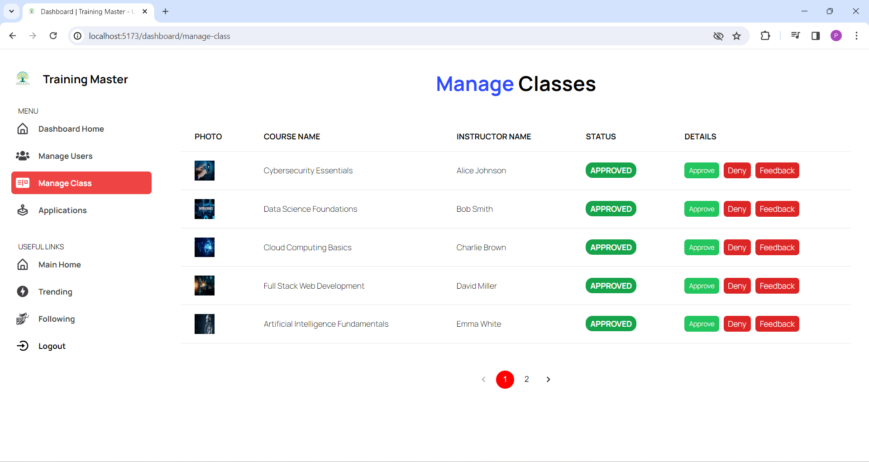

Figure 8.18 MANAGE CLASSES-APPROVED CLASS

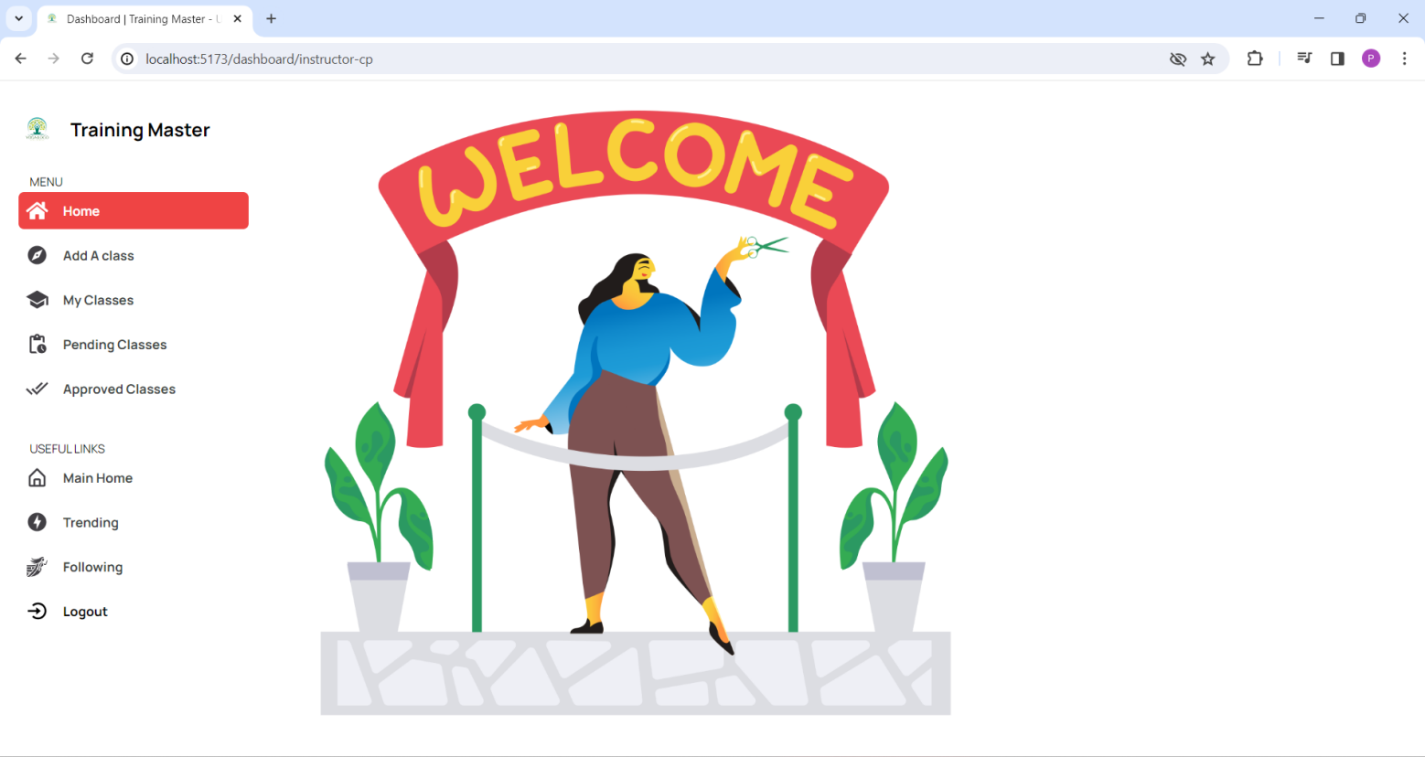

Figure 8.19 INSTRUCTOR DASHBOARD

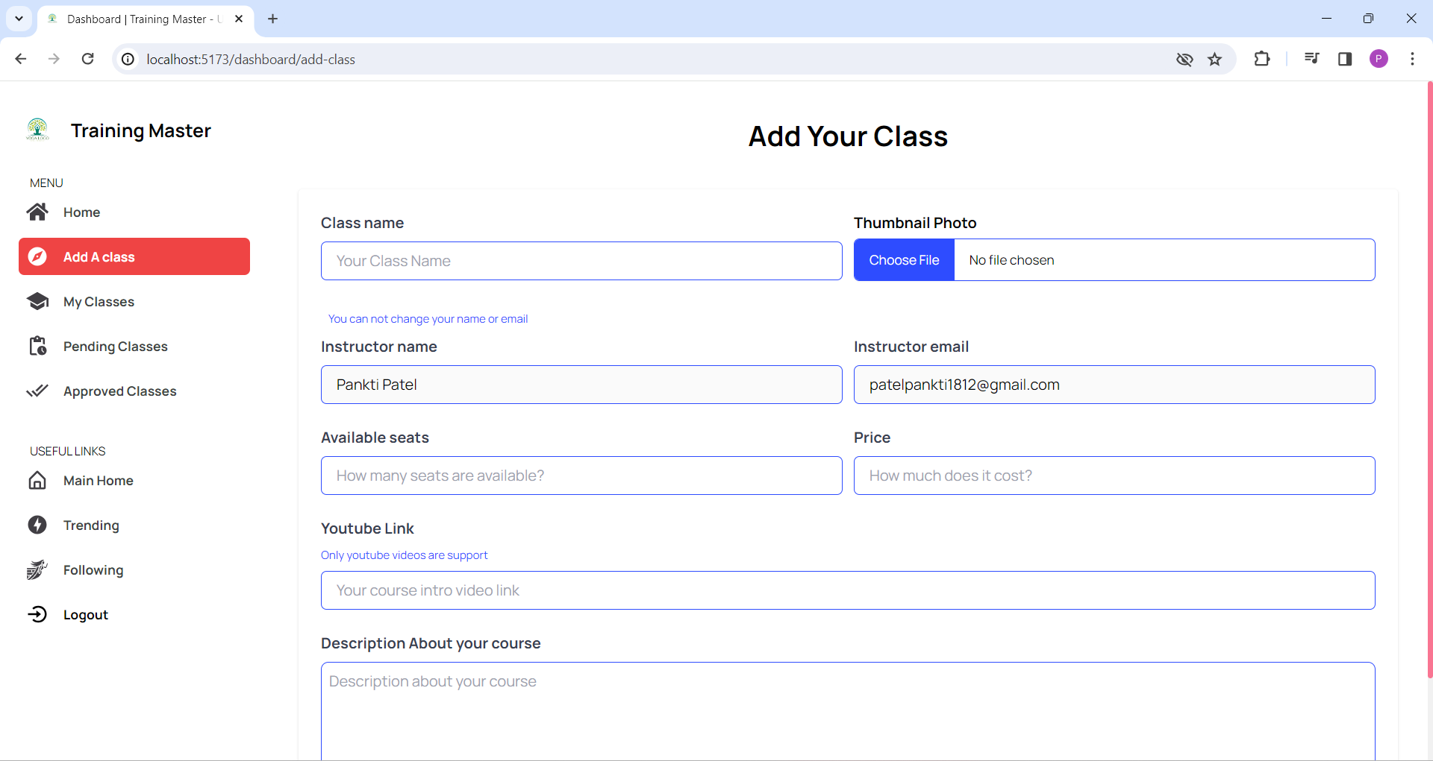

Figure 8.20 ADD YOUR CLASS

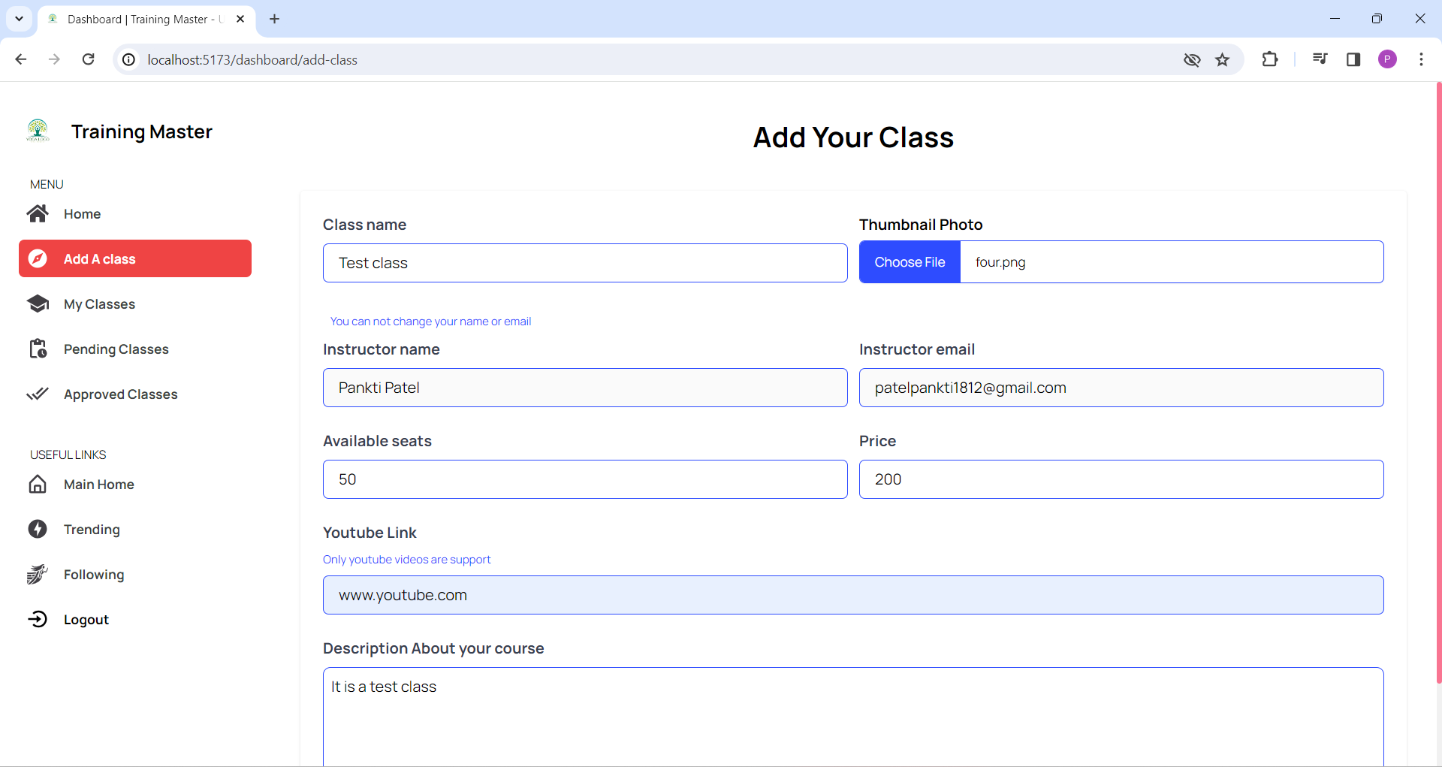

Figure 8.21 ADD YOUR CLASS DETAILS

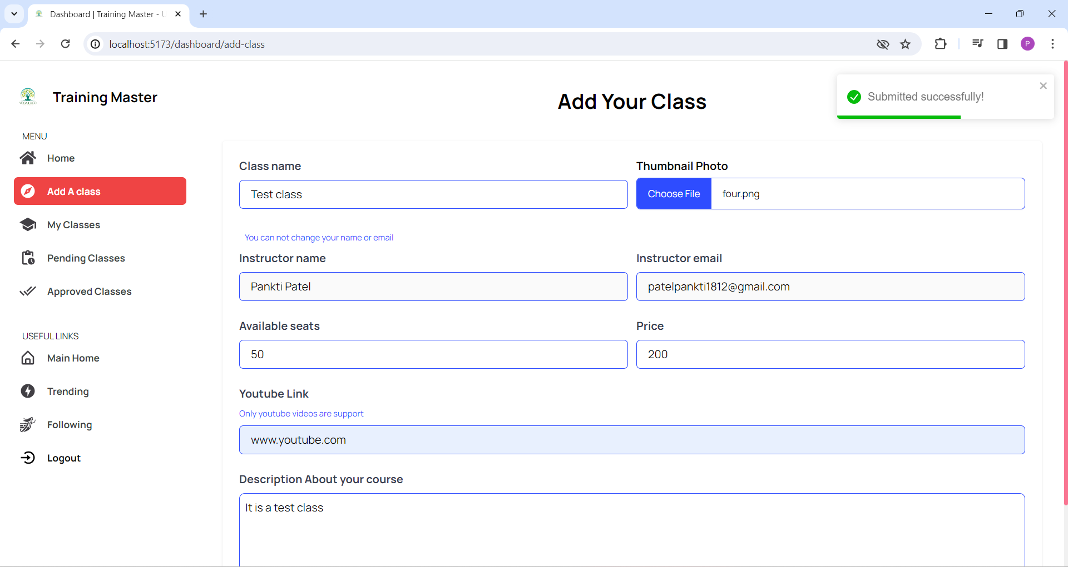

Figure 8.22 DETAILS SUBMITTED SUCCESSFULLY

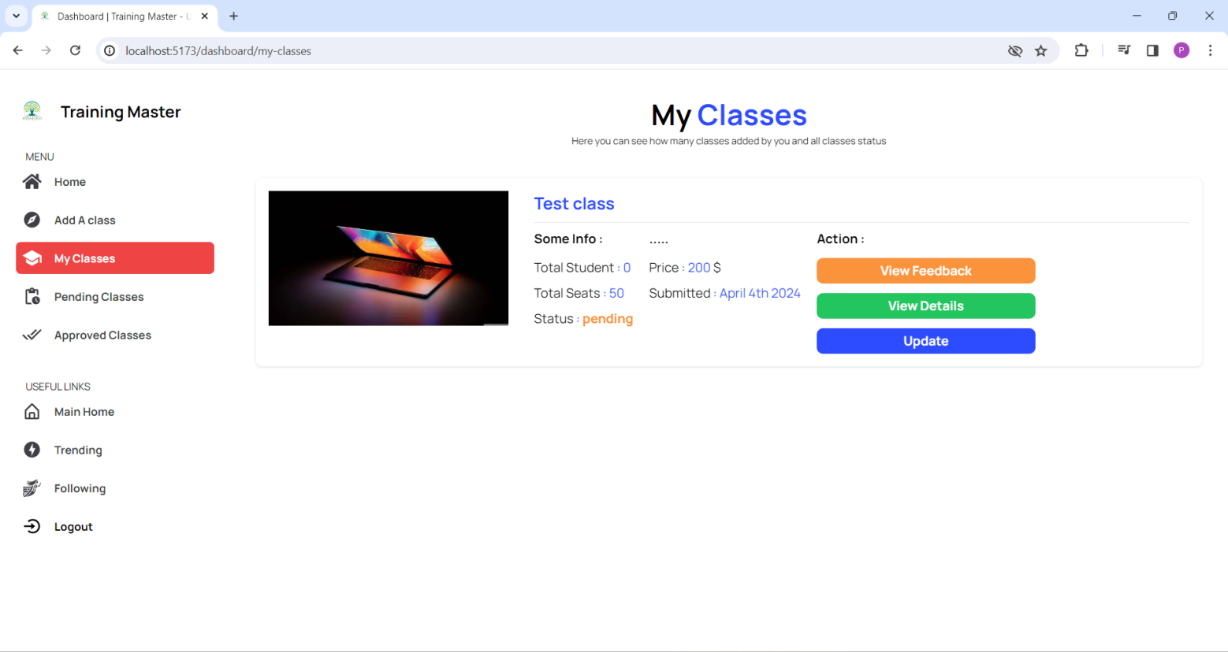

Figure 8.23 INSTRUCTOR CLASSES PAGE

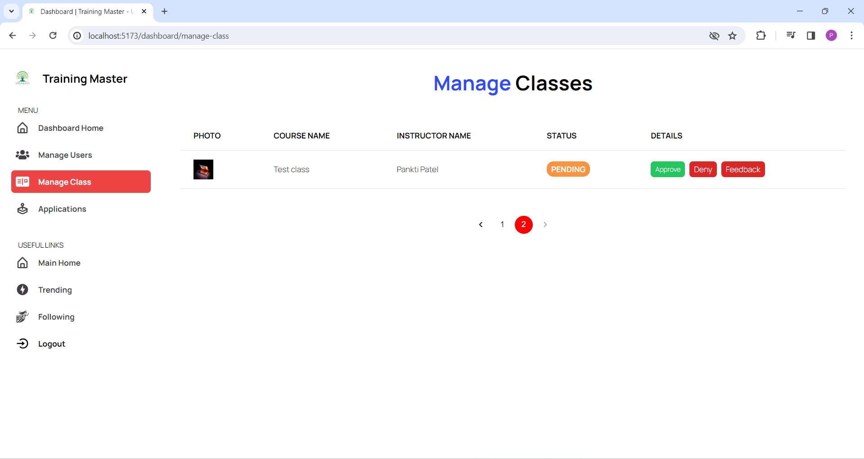

Figure 8.24 REQUEST IN ADMIN MODULE

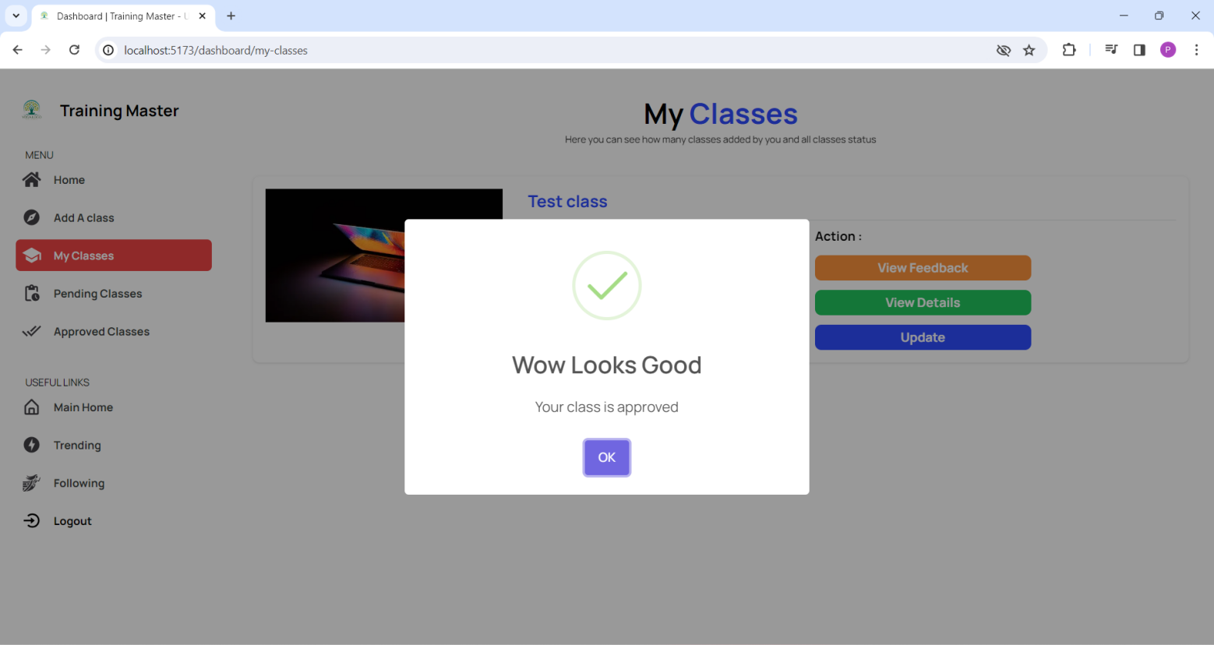

Figure 8.25 CLASS APPROVED BY ADMIN

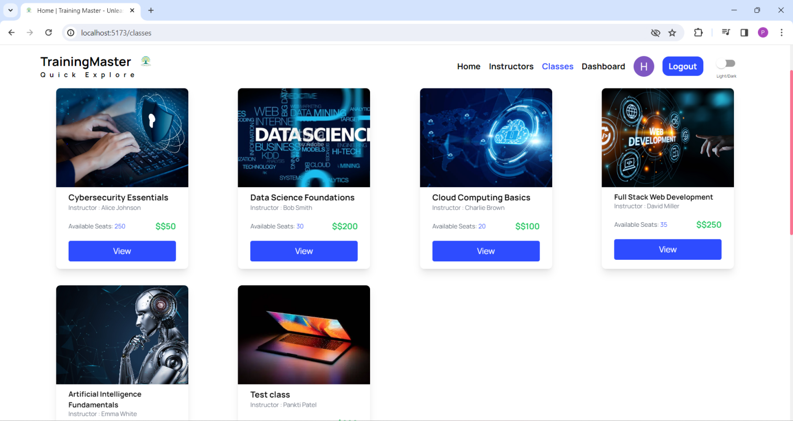

Figure 8.26 NEW CLASS ADDED TO CLASSES

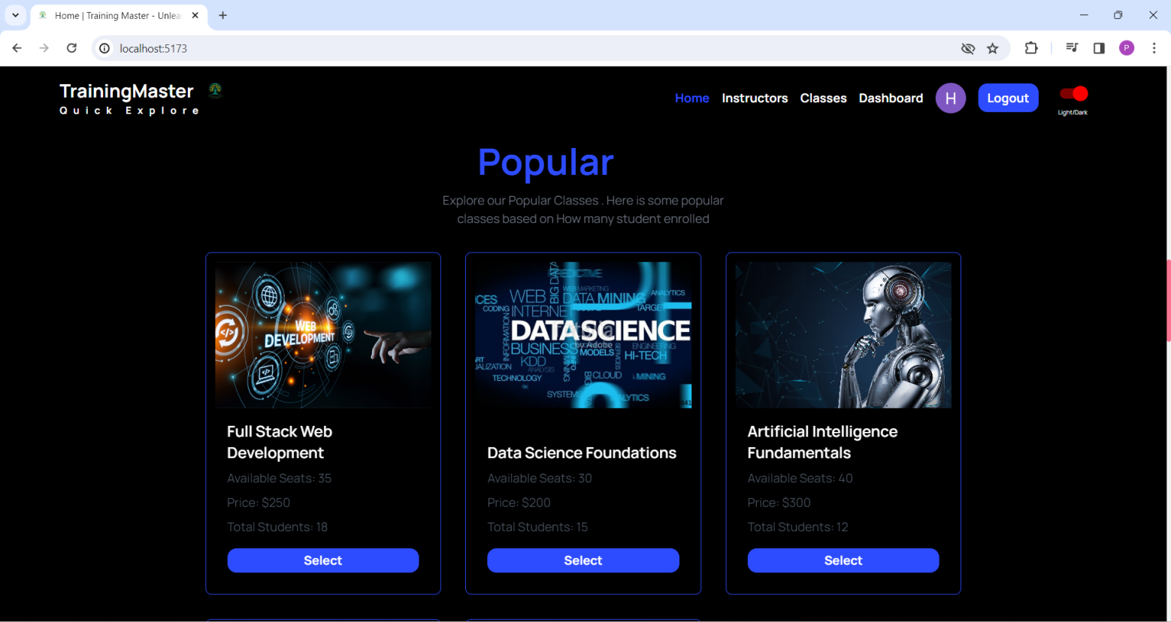

Figure 8.27 POPULAR CLASSSES- DARK MODE

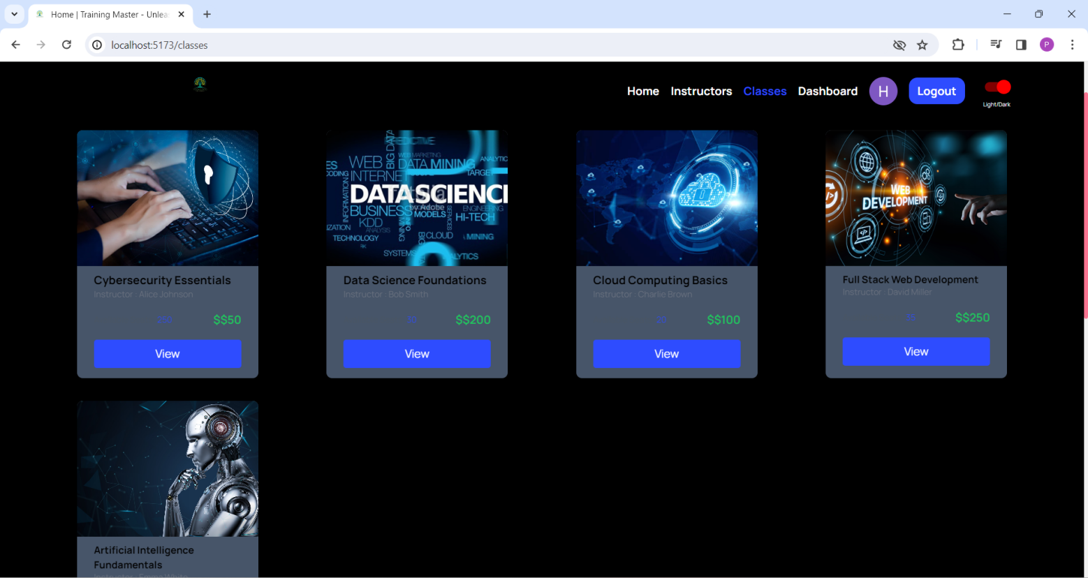

Figure 8.28 CLASSES- DARK MODE

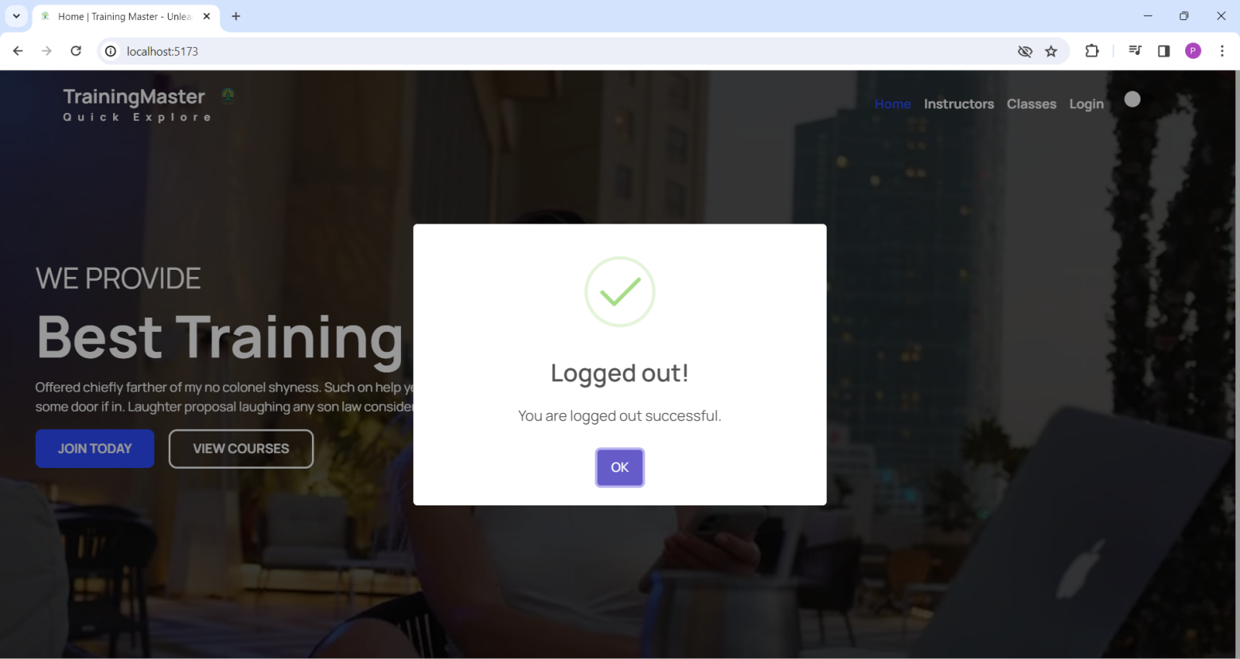

Figure 8.29 LOGOUT PAGE

# **LIMITATIONS AND FUTURE ENHANCEMENT**

## LIMITATIONS

* Currently our GUI is not good.
* Our system is not compatible to Run and Load this KNN based classification model.
* Our system can’t play the songs.
* Podcasts, story tell are not included yet.

## FUTURE ENHANCEMENTS

* I will improve the efficiency of the website.
* I will keep on the changing on UI-Design to make the application more attractive.
* I will add certified courses and quiz in it,
* I will try to add as much courses as possible.
* Also I can make research paper on this Project.
* Increase speed of embedding and compressing.
* I will implement notification sending system for new updates.

# **CONCLUSION AND DISCUSSION**

## CONCLUSION

* Software is easy to use but it requires user is pre-knowledge of system and refers the user manual.
* I provide ease to get training while working.
* I have tried to keep the UI alluring and easy enough for our users to feel comfortable
* I used MERN Stack to implement so no more complexity to handle vast

## DISCUSSION

### **Self-Analysis of Project Viabilities**

The viability of a music recommendation system hinges on its ability to accurately understand and anticipate user preferences, thereby enhancing user engagement and satisfaction. By leveraging advanced machine learning algorithms and data analytics, such a system can continuously adapt to evolving user tastes and preferences, offering personalized recommendations tailored to individual preferences and contexts. Furthermore, the system's integration across multiple platforms and devices, coupled with robust privacy controls, ensures widespread accessibility while safeguarding user data. Ultimately, a well-executed music recommendation system holds significant potential for fostering user loyalty, driving user retention, and generating revenue through targeted advertising and premium subscription models.

### **Problems Encountered and Possible Solutions**

There were so many problems encountered during this project: -

1. Problem to maintain databases and change them often.

2. Need to change some functionality fully which leads to doing the whole work again.

Like, fetch data from datasets – In these algorithms, it was very time consumption method and complex to run on every system

3.Many instances where the errors weren’t understandable.

4.Problem to integrate some functionalities.

### **Summary of Project Work**

We have completed our project work using software engineering, system analysis and design approach. We have done our work with planned scheduling pertaining to time constraints and result oriented progress in project development. We have been given an industrial exposure which is very beneficial for our field. This project will be able to recommend the music and can be further modified to music recommendation system. As it is platform independent, can be run in all environments.

## REFERENCES:

* <https://www.mongodb.com/products/tools/compass>
* <https://react.dev/>
* <https://expressjs.com/>
* <https://stripe.com/in>
* https://www.postman.com/